Navigating the Transition to College: LGBTQ+ Students’ High School Experiences and Academic Plans

Authors: Christina Sun, Alexandria Hurtt, and Michal Kurlaender

Abstract
Limited research considers the diversity of experience across gender identity and sexual orientation during the transition from high school to college. Drawing on the results of a large-scale survey (n = 9,230) of California high school seniors, we examine LGBTQ+ students’ high school experiences and college expectations, including their concerns about college prior to matriculation. Findings reveal there is a statistically significant difference between the high school experiences of cisgender students and transgender and gender expansive students, who, on average, report less positive experiences overall and substantially higher rates of identity-based bullying. While transgender and gender expansive students maintained higher levels of worry about discrimination compared to cisgender students, binary-identifying transgender students were more likely to report concerns about discrimination compared to nonbinary and other gender diverse students. Despite heightened concerns about discrimination, transgender and gender expansive students planned to enroll in college. These results carry implications for California education policy, including the need for targeted anti-bullying interventions, transition supports that build on student resilience, and continued collection and disaggregation of data by gender identity and sexual orientation.
Acknowledgements
This research was supported by the College Futures Foundation and conducted in partnership with the California Student Aid Commission. The authors are also grateful for ongoing support from the Stuart Foundation to the California Education Lab. The findings and conclusions here are those of the authors alone and do not necessarily reflect the positions or policies of the funders or of the California Student Aid Commission. The authors are also grateful to Elizabeth Friedmann, Sherrie Reed, Paco Martorell, Scott Carrell, Kairo Weber, Baiyu Zhou, Maria Charles, and Laurel Westbrook for their expertise and support in the construction of the survey, analysis, and/or review of findings.

Introduction
A critical choice students make in high school is whether or not to pursue a postsecondary education. This choice is shaped by students’ experiences in high school (Kurlaender et al., 2019; Reed et al., 2023; Uwah et al., 2008), which can influence their educational aspirations and expectations (Bergerson, 2009)— important predictors of later educational attainment (Jacob & Wilder, 2010; Sewell et al., 1969). Moreover, research has long documented differences in aspirations and expectations across student groups (Bergerson, 2009), including race/ethnicity, gender, and first-generation status (Kao & Tienda, 1998; Mau & Bikos, 2000; McCarron & Inkelas, 2006; Solorzano, 1992; Trusty, 2002), with recent studies drawing on more expansive definitions of gender identity and sexual orientation (Aragon et al., 2014; Feldman et al., 2022).
Despite this, gaps are still present in research examining the educational aspirations of different gender and sexual identities, including intended field of study in college. Given that lesbian, gay, bisexual, transgender, and queer (and/or questioning) (LGBTQ+) students are distinct groups (e.g., Beemyn, 2012; Nicolazzo, 2017; Watson et al., 2019), each of which likely experience school and the college-going process differently, it is important to interrogate the extent to which college aspirations and expectations differ by gender identity and sexual orientation. Moreover, as LGBTQ+ students frequently report experiencing harassment and discrimination in high school—often related to their sexual orientation, gender identity, and/or how they express their gender (Kosciw et al., 2021)—this may impact their specific academic aspirations and broader considerations about college, as school victimization can lead to lower levels of school belonging and self-esteem, high rates of absenteeism, and diminished academic outcomes, including college enrollment (Aragon et al., 2014; Heck et al., 2014; Kosciw et al., 2013; Sansone, 2019). In this case, how differences in LGBTQ+ students’ secondary experiences may affect their educational trajectories is also important to examine, particularly as federal protections for LGBTQ+ students have been rolled back in the current administration (Schultz, 2025). This work thus aims to examine associations between gender identity and specific academic aspirations (e.g., type of college, intended field of study) and college concerns among college-bound 12th graders in California. In addition, we evaluate whether any differences in students’ aspirations and expectations may be attributable, at least in part, to differences in high school experiences, including whether or not a student faced harassment or bullying.
Therefore, this study explores the following research questions: (1) Do students’ college aspirations and expectations differ by gender identity and sexual orientation?, and (2) if so, to what extent are these observed differences attributable to students’ high school experiences? Drawing on the results of a large-scale survey conducted in partnership with the state agency responsible for administering financial aid in California, we explore patterns in high school experiences and college expectations (including academic plans, concerns, and excitements) to investigate what LGBTQ+ students, particularly those that identify as transgender and gender expansive, consider ahead of the college transition. We specifically highlight trans and gender expansive students as they often face distinct social challenges cisgender LGB+ students may not experience at the same rate (James et al., 2016). In this case, by examining trans and gender expansive students in addition to other subgroups of the LGBTQ+ community, we can analyze potential inequalities students may experience and how this might influence the college transition process.
This study focuses on California students given the state’s broad diversity across demographics, geography, and postsecondary opportunities. California is a particularly important context for this analysis as the state has historically adopted more protective policies for LGBTQ+ students compared to other states (e.g., the FAIR Education Act, comprehensive anti-discrimination protections) and maintains one of the most diverse student populations in the nation.
This paper is organized as follows: First, we broadly review scholarship on gender identity and sexual orientation. We then situate our analysis within frameworks that center students’ situated contexts to account for the confluence of factors that may impact LGBTQ+ students’ college expectations and broader educational trajectory. Next, we outline our data sources and methodological approach, followed by our findings. Finally, we discuss the implications of these results and consider avenues for future research.

Defining Gender Identity and Sexual Orientation
Students use a variety of labels to describe both their gender identity and sexual orientation (Callis, 2014; Galupo et al., 2015), reflecting the fact that traditional binary labels (e.g., woman, man, heterosexual, homosexual) are often constraining descriptors for the complex ways individuals experience gender and sexuality (Hammack et al., 2022). Moreover, research suggests students are constructing their own identities through different labels (Watson et al., 2019; White et al., 2018). In this case, gender identities beyond the established binary are increasingly recognized and additional labels have also emerged to describe sexual orientation apart from those traditionally defined (Galupo et al., 2015). Although individuals continue to identify with traditional binary labels, many students now use a more expansive set of labels for both gender (e.g., nonbinary, genderfluid) and sexual orientation (e.g., asexual, queer) (Beemyn, 2022; Hammack et al., 2022). Additionally, not every individual may feel comfortable selecting a label, or may be unsure about which labels to select, with questioning and unsure commonly reported terms for both gender identity and sexual orientation (Watson et al., 2019; White et al., 2018). In this study, we utilize a novel dataset that acknowledges the spectrum of labels students may use to define their identities outside a binary construct and spotlight transgender, nonbinary, and gender diverse students in our analysis to enrich understanding of these students’ unique experiences navigating the high school to college transition.

Theoretical Background and Prior Literature
There are several factors that may influence how a student navigates the transition from high school to college, as it is a period shaped by a confluence of individual and institutional factors that can affect students’ educational expectations and later attainment (Kurlaender et al., 2019). In fact, one’s individual differences, relationships, the school one attends, and broader context and surroundings all play a role during this critical period (Luh et al., 2023; Pike & Robbins, 2016). At the student level, students’ individual attributes, such as motivation, self-efficacy, and academic performance, moderate their educational trajectory (CITE). Moreover, high school academic performance is associated with one’s aspirations to both two- and four-year colleges (DesJardins et al., 2019), suggesting that students’ perceptions of their chances of admission and success also guide their postsecondary ambitions.
Additionally, research has long demonstrated that various forms of social and cultural capital play a role in shaping students’ educational pathways (Bourdieu, 1986; Dumais & Ward, 2010; Merolla & Jackson, 2014; Plagens, 2011; Wells, 2008). For example, social capital (the resources available through one’s social networks) reveals how relationships with peers, family members, and others can support students’ acquisition of valuable information about the college application and enrollment process and develop stronger college-going attitudes and behaviors (Alvarado & An, 2015; Hill, 2008; Perna, 2000; Skobba et al., 2018). In this case, students that can navigate the socially constructed norms surrounding the college process, and whose networks provide access to academic and social resources for this transition, are more likely to enroll in college (Choi et al., 2008; Fletcher, 2015). As LGBTQ+ students often experience hostile social environments in schools and at home, caring adults and social support more broadly may be particularly important to the college-going process. Beyond social capital, research suggests LGBTQ+ students living in cis-normative environments exhibit particular strengths, or possess several types of queer cultural capital (Pennell, 2016). This includes navigational capital, or the ability to navigate schools and other institutional systems that are not always designed with LGBTQ+ students in mind. In this case, students must learn to navigate systems and spaces (e.g., cis-normative school and state policies about gendered restrooms, sports participation), potentially in creative ways, in order to access the psychological, social, cultural, and physical resources they need for their well-being (Pennell, 2016).
At the institutional level, schools shape students’ expectations of college and future educational attainment through the environments they cultivate (Eccles & Roeser, 2011; Uwah et al., 2008). A school culture characterized by high values and expectations for learning is associated with increased academic outcomes (Hattie, 2009), and school safety and climate are also critical to engagement, belongingness, and achievement (Osterman, 2000; Walton & Cohen, 2011). As schools may be unsafe learning environments for LGBTQ+ students, who often experience higher rates of bias-based bullying and victimization (Day et al., 2018), LGBTQ+ students’ perception of school climates may be inherently different than their cisgender heterosexual peers. Moreover, students’ schooling experiences are mediated by stressors that underlie societal conditions, including external (e.g., discrimination and violence) and internal stressors (e.g., expectations of prejudice, concealment, internalized stigmas). These stressors, heightened for LGBTQ+ students, can affect psycho-social outcomes (Hunter et al., 2021), ultimately influencing educational expectations and the transition from high school to college more broadly. For example, prior research indicates that transgender youth often experience gender-related victimization, particularly in secondary schools, which may lead to higher levels of emotional distress and lower levels of school belonging (McBride, 2021). Moreover, victimization, reduced feelings of school belonging, and emotional distress can have a negative effect on school attendance, academic performance, and expectations to enroll in a four-year college for all LGBTQ+ youth (Aragon et al., 2014). Altogether, research suggests students’ high school experiences influence their future educational behavior (Gong & Toutkoushian, 2024).
Our work is thus motivated by several interconnected frameworks to understand how LGBTQ+ students navigate the transition from high school to college. First, we draw on a newer model of college choice outlined by Klasik and colleagues (2025) that builds upon prior models (e.g., Hossler & Gallagher, 1987; Perna, 2006) to include expectations as a critical component in students’ predisposition for college. We examine the ways in which high school experiences influence students’ college expectations (including academic plans, concerns, and excitements) in the spring of their senior year and focus on an understudied and marginalized group: LGBTQ+ students.
As college expectations are context-dependent, this work is also framed by the social ecological theory of resilience (Ungar, 2011, 2012) to understand the potential variation in the college expectations of LGBTQ+ students, who must often navigate hostile environments and cis-normative policies at school and within society more generally (Kosciw et al., 2022). LGBTQ+ youth that faced harassment or social exclusion in high school may look towards college as a new opportunity to fit in, while those who did not struggle as much may have other concerns. Similarly, LGBTQ+ students that plan to live away from home while in college may feel increased trepidation (i.e., leaving familial support) or, in contrast, relief (i.e., escaping familial discomfort or hostility) (O’Neill & Conron et al., 2022). As college transitions vary across demographic differences, including gender (Means et al., 2016; Toutkoushian et al., 2018), students’ identities concurrently influence their lived experiences and expectations for their pathway to college (Feldman et al., 2022; Fotopoulou, 2012). Therefore, it is important to consider different elements of students’ identities in addition to how those identities are shaped by students’ networks and environment. In this case, the differences we observe in LGBTQ+ students’ expectations for college will reflect students’ experiences and the ways in which they navigate their own situated context.

Data and Methods

Survey Instrument and Sample Characteristics
In May 2023, in partnership with the California Student Aid Commission (CSAC)—the state agency responsible for administering financial aid programs for students attending public and private universities, colleges, and vocational postsecondary institutions in California—we administered a web-based survey to document the experiences of high school seniors planning to enroll in college. The survey was distributed to all seniors statewide that submitted either the Free Application for Federal Student Aid (FAFSA) or the California Dream Act Application (CADAA) for the 2023-24 academic year. A total of XX [number] students went sent an invitation to participate in the survey through CSAC; 10,221 completed surveys, including 9,230 respondents who indicated they planned to go to college, 170 who did not plan to attend, 294 that were unsure, and 527 who did not respond. Our response rate was XX percent. Students reported on varying dimensions of their high school experiences; the support they received in preparation for college; their academic interests and plans for postsecondary enrollment; and their concerns about college. Detailed information on gender identity and sexual orientation was also collected. Overall, 9,230 respondents completed surveys who indicated they were high school seniors and intended to enroll in college that fall. After excluding respondents who were missing information about gender identity (n = 1,708), sexual orientation (n = 1,749), race/ethnicity (n = 1,617), or parental education (n = 1,647), our final analytic sample included 7,522 participants. Table 1 reports the demographic characteristics of our analytical sample.
Table 1
Demographic Characteristics of 12th Grade Participants (N = 7,522), 2023
 | n | Percent
Panel A. Gender identity
Cisgender man | 2,675 | 35.6
Cisgender woman | 4,289 | 57.0
Transgender man | 59 | 0.8
Transgender woman | 20 | 0.3
Nonbinary | 267 | 3.6
Gender diverse/questioning | 71 | 0.9
Prefer not to say | 141 | 1.8
Total reported gender identity | 7,522 | 100.0
Panel B. Sexual orientation
Straight/heterosexual | 5,190 | 69.4
Gay or lesbian | 330 | 4.4
Bisexual/pansexual/omnisexual | 1,139 | 15.2
Asexual/aromantic/demisexual | 182 | 2.4
Other/queer/questioning | 131 | 1.8
Prefer not to say | 509 | 6.8
Total reported sexual orientation | 7,481 | 100.0
Panel C. Race/ethnicity
American Indian/Alaskan Native | 163 | 2.1
Black/African American | 532 | 7.0
Hispanic/Latinx | 3,793 | 49.8
Pacific Islander | 64 | 0.8
Filipino | 235 | 3.1
Asian | 1,146 | 15.1
Other | 182 | 2.4
White/non-Hispanic | 1,498 | 19.7
Total reported race/ethnicity | 7,613 | 100.0
Panel D. Highest level of education among parents
Did not complete high school | 1,373 | 18.1
High school diploma | 1,578 | 20.8
Some college, no college degree | 975 | 12.9
Associate degree | 452 | 6.0
Bachelor's degree | 1,363 | 17.9
Graduate/Professional degree | 1,455 | 19.2
Don’t know | 387 | 5.1
Total reported parental education | 7,583 | 100.0

To collect data on gender identity, we adopted the two-step approach recommended by the GenIUSS group (Herman, 2014) given its high sensitivity and specificity in accurately discriminating between transgender and cisgender respondents (Herman, 2014; Saperstein & Westbrook, 2021). This approach includes two questions: (1) What is your sex assigned at birth, on your original birth certificate?, with male and female as response options; and (2) What is your current gender identity?, with woman, man, nonbinary, prefer not to say, and other as response options. Respondents who chose other also had the option to write in a response. Using these survey items, we classify respondents into one of the following umbrella categories: cisgender, transgender and gender expansive (Robinson & Cooper, 2024), and prefer not to say. Respondents who reported that their sex assigned at birth aligned with their current gender identity (e.g., male and man; female and woman) were categorized as cisgender, while respondents who reported their sex assigned at birth differed from their current gender identity were categorized as trans(gender) and gender expansive. The Human Rights Campaign uses the term trans(gender) and gender expansive to describe “the collective community of individuals whose gender identities, gender presentations and expressions, and/or lived experiences differ from those typically associated with the sex they were assigned at birth” (Robinson & Cooper, 2024). Here, we adopt this collective umbrella term to refer to all respondents who identified differently than their sex assigned at birth while recognizing that “trans” and “gender expansive” are not necessarily distinct or mutually exclusive identities, and that some may not use these labels to describe their personal identity.
We further classify trans and gender expansive students into the following sub-categories, which we utilize in our analysis: transgender men, transgender women, nonbinary, and gender diverse/questioning. For example, students who reported their sex assigned at birth as female or male and who identified as a man or a woman were categorized as binary-identifying transgender men and women, respectively. Students who selected nonbinary or wrote in responses that included the term “nonbinary” in their written responses were categorized as nonbinary, regardless of sex assigned at birth. Students who wrote in other diverse gender identities (e.g., genderfluid) are captured by the term gender diverse/questioning. Our analysis revealed some significant differences between the experiences of nonbinary and gender diverse/questioning students, which provides additional support for these distinctions. Finally, students who chose prefer not to say or wrote in malicious responses (e.g., racial and gender slurs) were classified as prefer not to say. Among the trans and gender expansive students in our sample (n = 417), about 19% identified as transgender, 64% as nonbinary, and 17% as gender diverse/questioning. Beyond predefined options, students also noted 26 unique terms to describe their gender identity, including genderfluid, agender, genderqueer, and two-spirit, among many others. We also examined associations between gender identity and sexual orientation and found that trans and gender expansive students were more likely to select a non-heterosexual sexual orientation than cisgender students (see Table A1 in Appendix A).
To measure sexual orientation, we adapted the survey instrument recommended by the Sexual Minority Assessment Research Team (SMART) to capture the breadth of students’ identities. Students were asked to self-identify among the following options: lesbian or gay; straight (not gay or lesbian); bisexual; asexual; prefer not to say; and other, which also included the opportunity to write in a response (Badgett et al., 2009). The option asexual was added to proffer more expansive options for students. Within our sample, nearly one-quarter (n = 1,782) of students identified as LGB+, with most students identifying as bisexual/pansexual/omnisexual (15.2%), while about 4% of students identified as gay or lesbian, 2.4% as asexual/aromantic/demisexual, and 1.8% as other/queer/questioning. Similar to gender identity, students also used a variety of terms to describe their sexual orientation beyond those provided, such as pansexual and queer, while others used multiple terms or did not want to label their sexual orientation.
A full descriptive examination of the rich diversity of labels students used to describe their gender identities and sexual orientation in the open response option, beyond those provided, is included in a companion paper currently under review (Hurtt et al., 2026, forthcoming). Here, we turn to how LGBTQ+ identities relate to students’ high school experiences and college expectations.

Data Analysis
We examine four main areas: high school experience, bullying and harassment, concerns about college, and post-secondary educational plans - including intended field of study, enrollment intentions, and degree aspiration.
To measure high school experience, we construct an additive index from six survey items: students’ ratings of their high school academic experience, social experience, sense of belonging in their school community, whether teachers and staff cared about their future, quality of college advising, and feelings of preparedness for college. All items range from -2 to 2, with -2 indicating a very negative experience, 2 indicating a very positive experience, and 0 indicating a neutral experience. We construct an additive (equally weighted) index using these items given the internal consistency of the items (Cronbach’s alpha = 0.74). The index for high school experiences ranges from -12 to 12, with higher values indicating more positive high school experiences. To explore differences in high school experience by gender, we regress the high school experience index on gender identity, first in an unconditional model and then adding controls for race/ethnicity and parental education.
We also descriptively examine rates of experiencing bullying and harassment in high school, disaggregated by gender identity and sexual orientation. For students who reported being bullied at least once, we further examine whether they attributed the bullying to their gender identity or sexual orientation.
To examine college concerns, we analyze the battery of 12 survey items, which asked students to rate how worried they were about their upcoming college experience on a four-point Likert scale (0 = "Not at all worried", 1 = “Slightly worried”, 2 = “Somewhat worried”, and 3 = "Very worried"). Eight items captured general concerns: affording tuition, living expenses, performing well academically, balancing work obligations, balancing family obligations, finding community, living away from home, and having adequate support for emotional and mental health needs. Four items captured concerns about discrimination: discrimination based on race, gender identity, sexual orientation, and religion (see Appendix C and D for disaggregation of each item by gender identity and sexual orientation, respectively).
We assessed the internal consistency of the 12 items using Cronbach’s alpha (0.80) and then performed principal component analysis (PCA) to identify underlying dimensions of college worry. We retained components with eigenvalues greater than 1.0, which identified three principal components. We then constructed a composite worry index for each retained component for every student as a weighted sum of the student’s responses to the 12 worry items, with weights given by the eigenvector of the corresponding component. The first component, which we label as general worries, loads broadly across most items and captures overall anxiety about the college transition. The second component, worries about discrimination, loads most heavily on the four discrimination items. The third component, worries about financial burdens, loads primarily on the tuition and living expense items. Each index is a continuous measure, with higher values indicating greater concern along that dimension.
We then use regression analysis to explore potential differences in the level of each type of worry by gender identity. We estimate three different specifications in our analysis: (1) an unconditional model with gender identity alone; (2) a model controlling for student demographics (i.e., the full set of race/ethnicity and parental education indicators); and (3) a model that controls for student demographics and high school experience index.

We examine post-secondary educational plans along three dimensions. First, we tabulate intended field of study by gender identity (Table 4). Second, we estimate logit models for intent to attend a four-year (versus two-year) college. Third, we estimate ordered logit models for highest degree aspirations, where the outcome is an ordinal measure with five categories: vocational/technical certificate, associate degree, bachelor’s degree, master’s degree, and doctoral degree. The logit and ordered logit models are estimated separately by gender identity and sexual orientation. In each case, we estimate an unconditional model and a model with controls for race/ethnicity and parent education. For sexual orientation models, we additionally estimate a specification that controls for assigned sex at birth. Cisgender men and straight/heterosexual students serve as the reference categories. We report odds ratios with 95% confidence intervals and present predicted probabilities from the ordered logit models as a stacked bar chart, evaluated at sample means.

Findings
High School Experiences
Students were first asked about their academic and social experiences in high school. We included a total of six Likert-scale survey questions on high school experiences, with each item ranging from -2 (very negative) to 2 (very positive), with 0 indicating a neutral experience (see Appendix B for high school experience survey items and summary statistics). We constructed an additive index by summing these six items, yielding a scale ranging from -12 to 12, where positive values denote an overall positive experience, negative values indicate an overall negative experience, and zero suggests a neutral experience. For summary statistics of survey items over the entire sample, see Appendix B. For summary statistics of survey items disaggregated by gender identity and sexual orientation, see Appendix C.
We first compare average high school experiences by gender identity (Table 2). Cisgender men report the most positive high school experiences (mean = 4.27), followed by cisgender women (mean = 3.79). Trans and gender expansive students report substantially less positive experiences, with gender diverse/questioning students reporting the lowest scores (mean = 1.11). We plot these differences as regression coefficients in Figure 3 and find them statistically significant and robust to the inclusion of demographic controls. While not causal, these results indicate that there is an association between gender identity and students’ experiences in high school, which we consider in later analyses.

Table 2
General High School Experience by Gender Identity
 | N | Mean
Cisgender man | 2,659 | 4.3
Cisgender woman | 4,269 | 3.8
Transgender man | 59 | 2.4
Transgender woman | 20 | 2.6
Nonbinary | 267 | 2.3
Gender diverse/questioning | 71 | 1.1
Prefer not to say | 138 | 2.2
Total | 7,483 | 3.8
Note. The general high school experience index only applies to students who reported non-missing values for all six high school experience items and ranges from -12 to 12 (negative values indicate a negative experience, positive values indicate a positive experience, and zero indicates a neutral experience). High school experience items are available in Appendices B and C

Figure 1
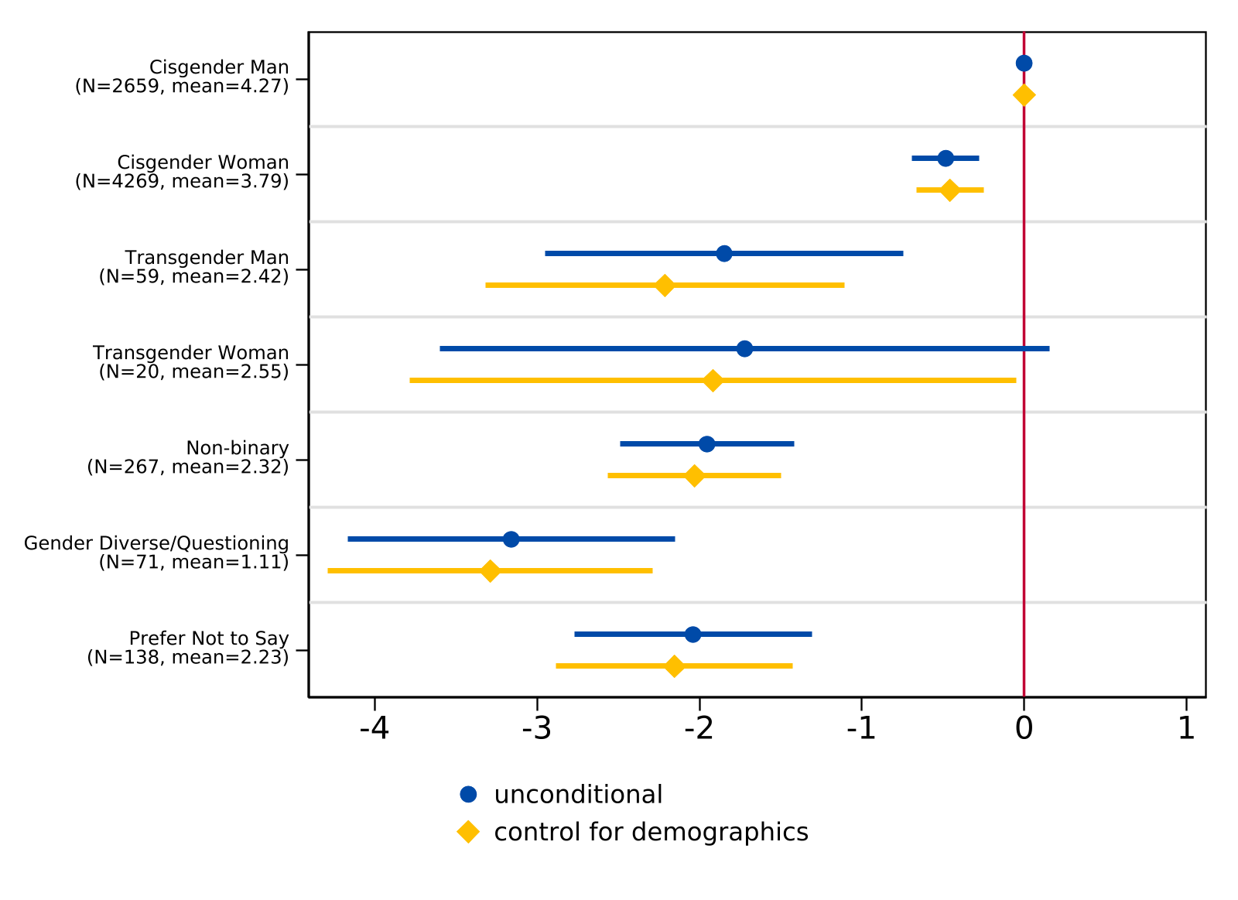
Regression of High School Experience Index on Gender Identity
Note. For the unconditional model, n = 7,483. For the model controlling for demographics (race/ethnicity and parental level of education), n = 7,464. The lines indicate 95 percent confidence intervals while the sample frequency and mean index of each gender identity are reported in parentheses. The vertical line at 0 represents the coefficient for the reference group (cisgender man).

We observe a similar pattern by sexual orientation. Relative to straight/heterosexual students (mean = 4.13), all other sexual orientation groups report significantly lower high school experience scores. Students who prefer not to disclose their sexual orientation (mean = 2.91) and bisexual/pansexual/omnisexual students (mean = 3.12) report the largest gaps, while asexual/aromantic/demisexual students (mean = 3.68) and gay or lesbian students (mean = 3.55) report somewhat smaller but still significant differences. These differences are attenuated but remain statistically significant after controlling for race/ethnicity and parental education, as well as assigned sex at birth. While not causal, these results indicate that there is an association between both gender identity and sexual orientation and students' experiences in high school, which we consider in later analyses.

Table X
General High School Experience by Sexual Orientation
 | N | Mean
Straight/Heterosexual | 5159 | 4.1
Gay or Lesbian | 329 | 3.6
Bisexual/Pansexual/Omnisexual | 1136 | 3.1
Asexual/Aromantic/Demisexual | 182 | 3.7
Other/Queer/Questioning | 131 | 3.2
Prefer Not to Say | 505 | 2.9
Total | 7442 | 3.8
Note. The general high school experience index only applies to students who reported non-missing values for all six high school experience items and ranges from -12 to 12 (negative values indicate a negative experience, positive values indicate a positive experience, and zero indicates a neutral experience). High school experience items are available in Appendices B and C.

Figure X
Regression of High School Experience Index on Sexual Orientation
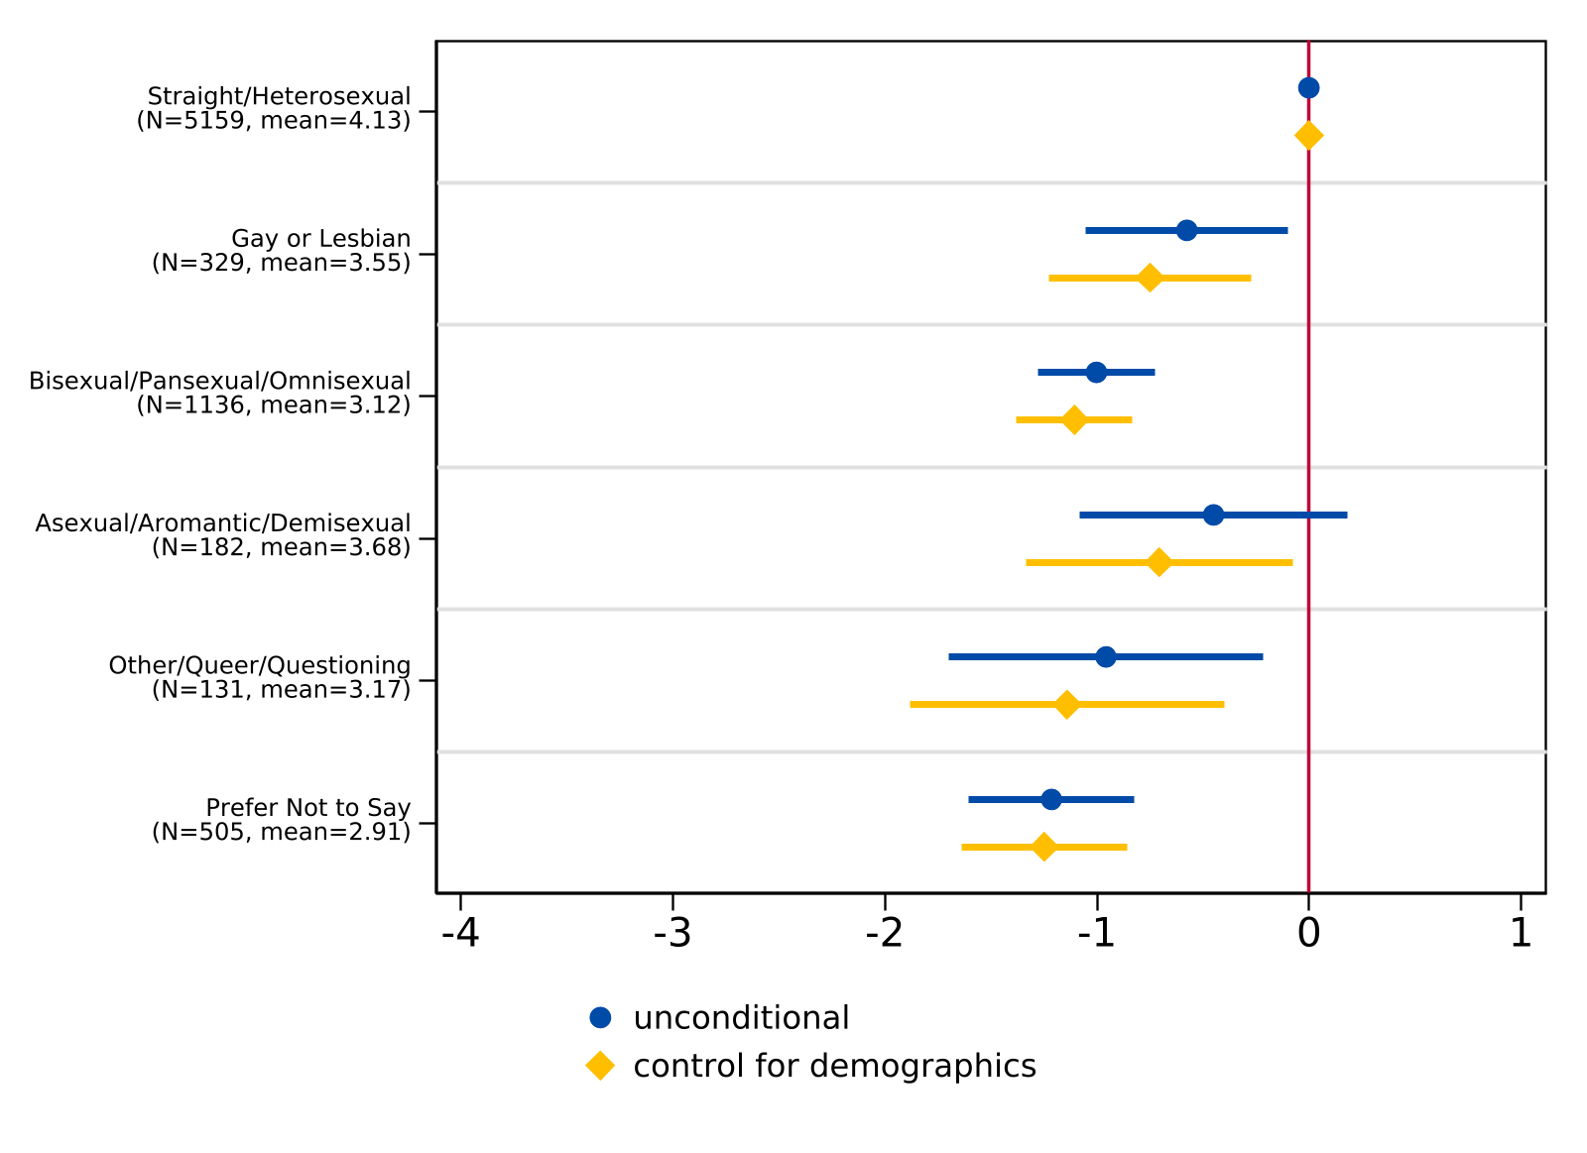
Note. For the unconditional model, n = 7,483. For the model controlling for demographics (race/ethnicity and parental level of education), n = 7,464. The lines indicate 95 percent confidence intervals while the sample frequency and mean index of each sexual orientation are reported in parentheses. The vertical line at 0 represents the coefficient for the reference group (straight/heterosexual).

Bullying in High School
We also included two survey questions to understand the extent to which students may have experienced bullying or harassment while in high school. First, we asked students the number of times they were bullied or harassed at school in the last 12 months (response options included 0 times, 1 time, 2-3 times, and 4 or more times). For students who reported being bullied at least once, students were also asked about the reasons they were harassed or bullied (i.e., race or ethnicity, religion, gender identity, or sexual orientation).
Figure 2 presents the frequency of bullying by gender identity and sexual orientation. Across all respondents, approximately 77% of students reported not being bullied or harassed on school property in the past year, while roughly 10% reported being bullied once, 9% reported being bullied two to three times, and about 4% reported being bullied four or more times. However, these rates varied considerably by gender identity. Among cisgender men, nearly 84% reported no bullying compared to only about 35% of transgender students and 54% of nonbinary and gender diverse/questioning students. Moreover, transgender students reported the highest rates of repeated victimization, with approximately 27% experiencing bullying two to three times and nearly 16% experiencing bullying four or more times — rates far exceeding those of any other gender identity group. Nonbinary and gender diverse/questioning students also reported elevated rates of bullying relative to their cisgender peers, with roughly 23% reporting two to three incidents and about 10% reporting four or more.
Patterns by sexual orientation revealed similar disparities. While approximately 82% of straight/heterosexual students reported no bullying in the past year, this figure dropped to about 61% for gay or lesbian students and 62% for bisexual, pansexual, and omnisexual students. Students identifying as other, queer, or questioning also reported lower rates of no bullying (about 60%) and higher rates of repeated victimization compared to their heterosexual peers. Asexual, aromantic, and demisexual students reported rates closer to the overall average, though still below those of heterosexual students.
Figure 2
Frequency of Bullying/Harassment in the Past Year

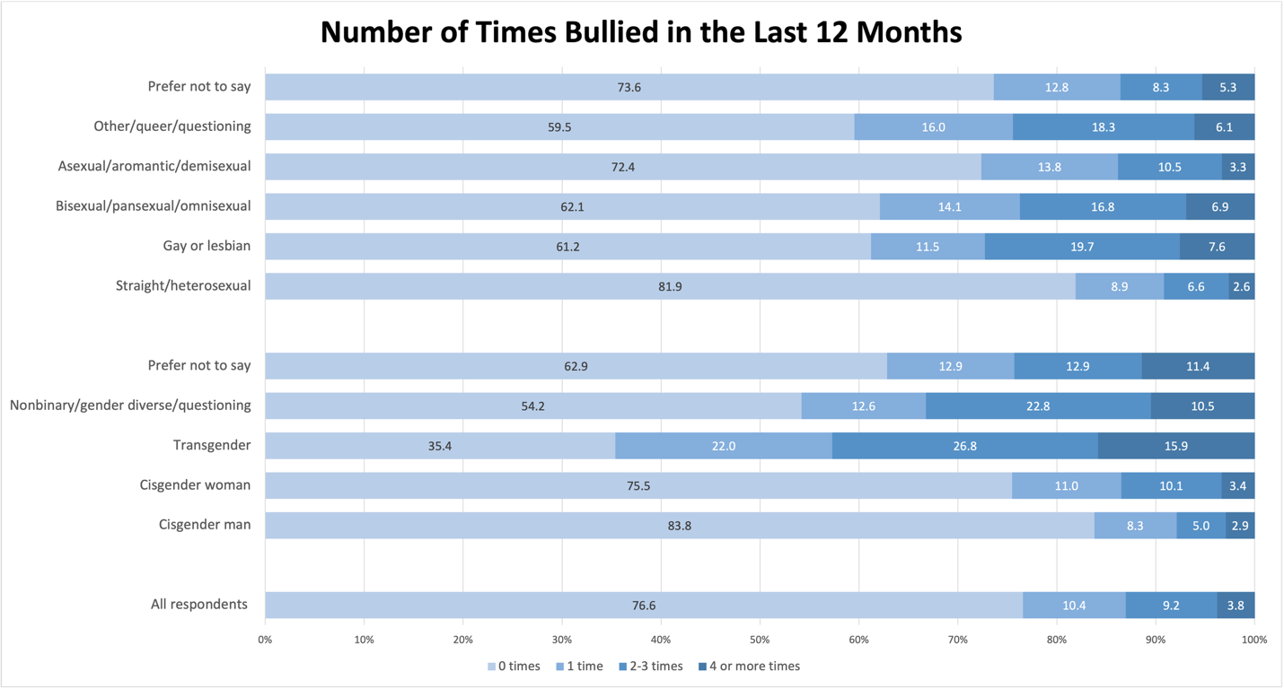
Note. Rates depicted in the figure represent the sample of students that responded to questions about bullying and harassment (n = 7,512 for disaggregation by gender, and n = 7,471 for disaggregation by sexual orientation). The omitted group is students that selected they were not bullied (i.e., “0 times”).
Among students who reported being bullied one or more times, we further examined whether students attributed the bullying to their gender identity or sexual orientation (Figure 3). Overall, about 55% of students that were bullied indicated they had been harassed because of their gender or sexual orientation. This figure, however, masks stark differences across identity groups. Among transgender students who reported being bullied (n = 42), all attributed the bullying to their gender or sexual orientation, and nearly 88% of nonbinary and gender diverse/questioning students who were bullied reported the same. In contrast, only about 35% of cisgender men and 51% of cisgender women who were bullied attributed it to gender or sexual orientation. Disparities were just as pronounced across sexual orientation: approximately 97% of gay or lesbian students who experienced bullying reported it was related to their gender or sexual orientation, compared to about 77% of bisexual, pansexual, and omnisexual students and only 28% of straight/heterosexual students. These patterns underscore that trans and gender expansive students and sexual minority students not only experience higher rates of bullying overall, but are also disproportionately targeted because of their identity — a finding consistent with prior research documenting the heightened risk of bias-based victimization among LGBTQ+ youth (Day et al., 2018; Kosciw et al., 2022).
Figure 3
Student Responses to “During the past 12 months, were you harassed or bullied for your gender identity or sexual orientation?”
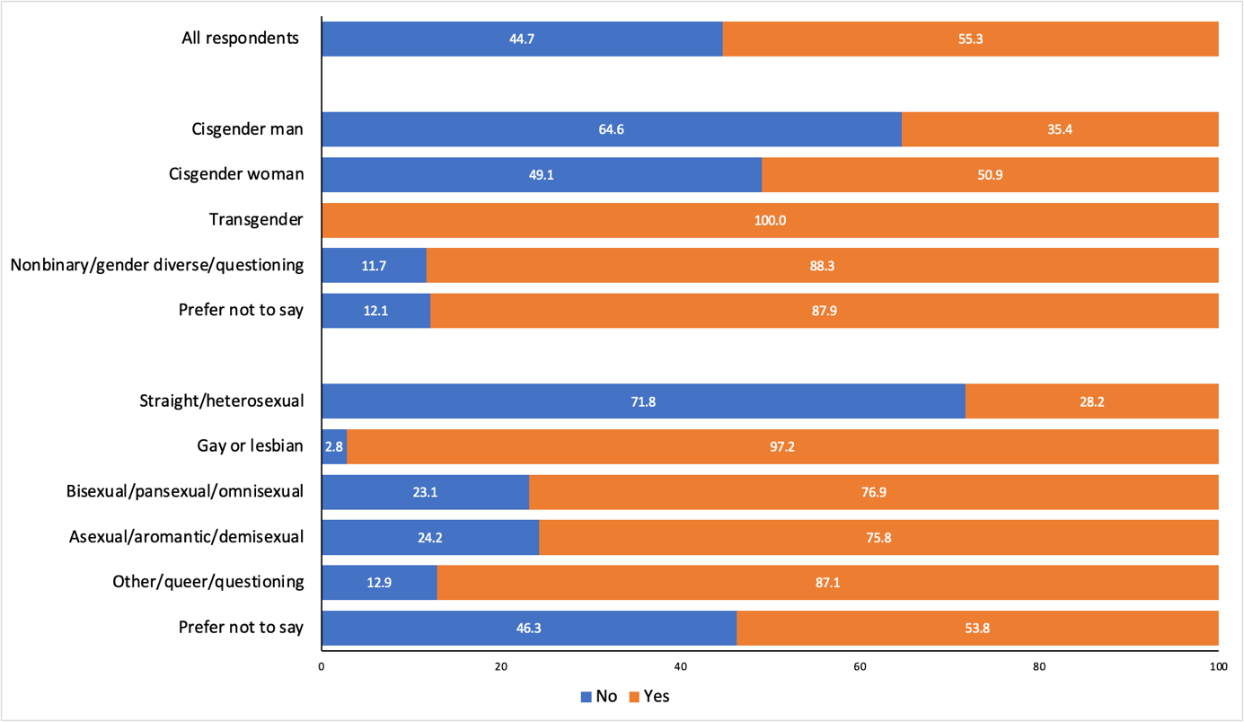
Note. Rates depicted in the figure represent the sample of students that reported being bullied or harassed more than once (n = 960 for disaggregation by gender, and n = 958 for disaggregation by sexual orientation).
Together, these patterns paint a troubling picture of the high school climate for trans and gender expansive students and sexual minority students more broadly. Not only are these students bullied at substantially higher rates, but the bullying they experience is overwhelmingly tied to their identity. Importantly, these experiences do not exist in isolation from students’ expectations for college. As we examine in the following section, the elevated rates of identity-based victimization documented here likely contribute to the heightened worries about discrimination that trans and gender expansive students report ahead of the college transition, even as students simultaneously express excitement about the possibility of finding safer, more affirming postsecondary environments.

Concerns About College
Students were also asked about their concerns ahead of the transition to college (Table 3). Answers to each question ranged from 0 to 3, in which a higher value corresponded with a higher level of concern. Using PCA, we found that students’ worries about the transition to college can be divided into three dimensions: (1) general worries; (2) worries about discrimination (including gender, sexuality, race, and religion); and (3) worries about financial burdens (including tuition and living costs). For summary statistics of the survey items used to construct these dimensions by gender identity and sexual orientation, see Appendix D. Together, these components explained 56.0% of the variance in overall worries about the transition to college. We constructed three indices of worries using PCA eigenvectors (summary statistics of the PCA constructs are reported in Table 8).
Table 3
College Concern Items and Results from Principal Component Analysis (PCA)
 | N | Mean
Items:
How worried are you about…
Affording tuition fees? | 7,957 | 1.8
Living expenses? | 7,956 | 1.7
Performing well academically? | 7,958 | 1.5
Balancing work obligations? | 7,943 | 1.6
Balancing family obligations? | 7,941 | 1.1
Finding community? | 7,934 | 1.3
Living away from home? | 7,948 | .9
Having adequate support for emotional and mental health needs? | 7,944 | 1.1
Discrimination based on gender? | 7,886 | 0.4
Discrimination based on sexual orientation? | 7,876 | 0.3
Discrimination based on race? | 7,895 | 0.5
Discrimination based on religion? | 7,891 | 0.2
PCA Constructs:
General worries (32.03%) | 7,706 | 3.8
Worries about discrimination (13.79%) | 7,706 | 1.2
Worries about financial burdens (10.26%) | 7,706 | 0.6
Note. The first twelve rows are survey items related to college worries. Each item ranges from 0 (not worried at all) to 3 (very worried). The last three rows indicate the three constructs: (1) general worries ranges from 0 to 10.23; (2) worries about discrimination ranges from -3.83 to 5.12; and (3) worries about financial burdens ranges from -3.64 to 3.65. Constructs were only created for high school students that reported non-missing values for all twelve items. The PCA proportion explained is reported in parentheses after each construct.
In terms of broad concerns, we find trans and gender expansive students experience a higher level of general worries compared to cisgender students. When we correlated these worries to students’ high school experiences, there appeared to be a negative, fairly weak correlation between high school experience and general worries about college; that is, students who reported more negative experiences in high school, on average, reported more worries. However, there is almost no correlation between high school experience and worries about discrimination or financial burdens, respectively.
Figures 6 through 8 present ordinary least squares (OLS) regression estimates for each component of worry by gender identity both with and without controls for high school experiences and demographics. In all regressions, cisgender men was set as the baseline comparison category. The point estimates represent the difference in a component of worry for each gender identity relative to cisgender men. The blue dots show the point estimates of the unconditional OLS estimates, while the yellow dots indicate OLS estimates that include race/ethnicity indicators, parental education indicators, and the constructed high school experience index as covariates. The lines represent 95% confidence intervals, which indicate if the estimated difference is statistically significant from cisgender men.
Regression estimates for general college worries on gender categories are presented in Figure 6. Among trans and gender expansive students, we find no statistical differences in general worries between different gender identities. That is, the general worries of transgender men, transgender women, and nonbinary or gender questioning students was significantly higher than cisgender men, but not significantly different from each other.

Figure 4
Regression of General College Worries on Gender Identity Categories
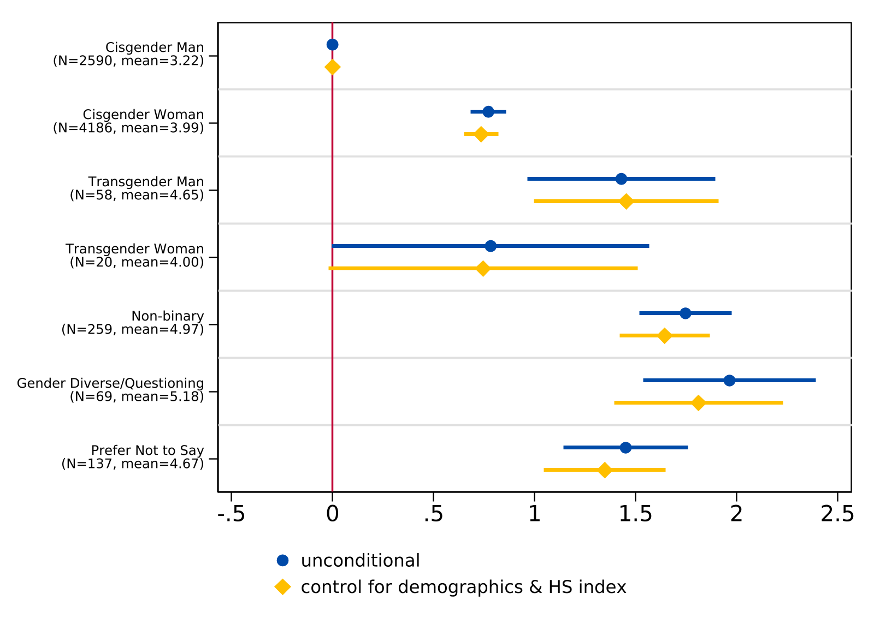
Note. We estimate regression models with gender indicators for an unconditional model (n = 7,319) and include race/ethnicity indicators, parental education indicators, and a constructed high school experience index as covariates for the specification with control variables (n = 7,276). The lines indicate 95 percent confidence intervals while the sample frequency and mean for each gender identity are reported in parentheses. The vertical line at 0 represents the coefficient for the reference group (cisgender man).
Additionally, results illustrate that trans and gender expansive students maintain higher levels of worry about discrimination compared to cisgender students (Figure 7), as the magnitude of the difference between transgender men and cisgender men exceeds the mean level of worry about discrimination for cisgender men. Additionally, among trans and gender expansive students, transgender students report higher levels of worry about discrimination compared to nonbinary and gender diverse/questioning students, although this estimate is somewhat noisy due to sample size. Finally, Figure 8 suggests that worries about financial burdens do not differ by gender identity.
Figure 5
Regression of Worries about Discrimination on Gender Identity Categories
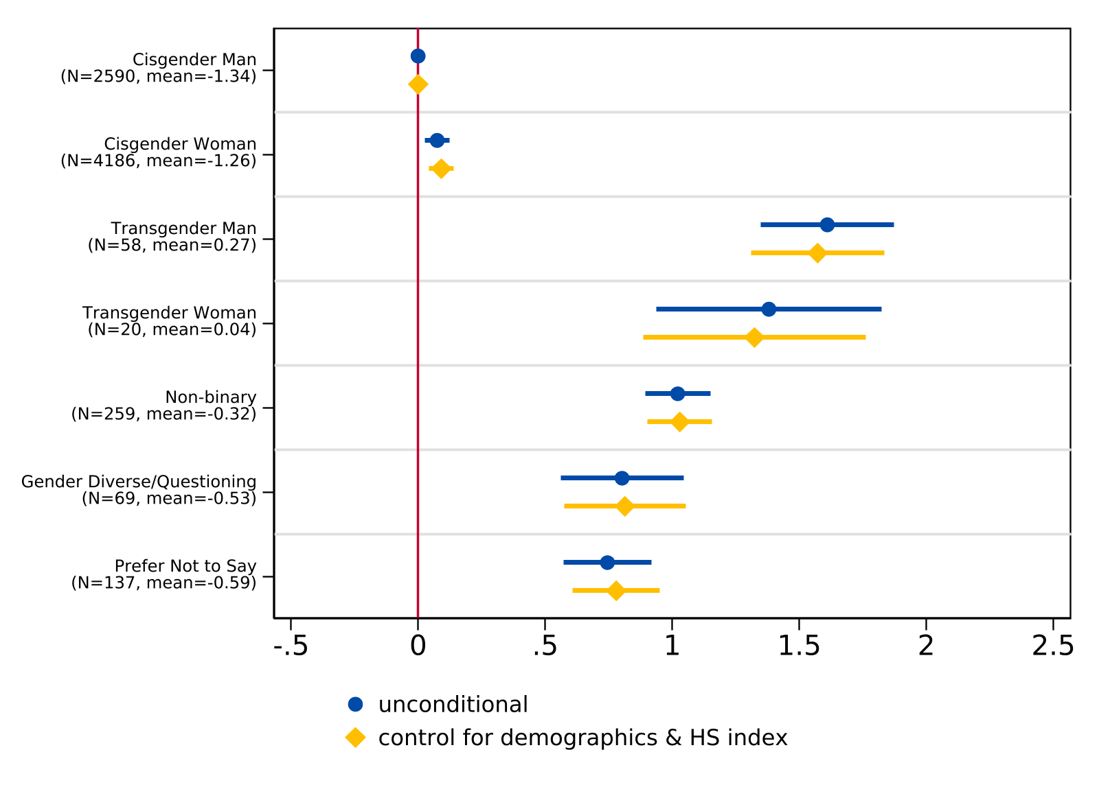
Note. We estimate regression models with gender indicators for an unconditional model (n = 7,319) and include race/ethnicity indicators, parental education indicators, and a constructed high school experience index as covariates for the specification with control variables (n = 7,276). The lines indicate 95 percent confidence intervals while the sample frequency and mean for each gender identity are reported in parentheses. The vertical line at 0 represents the coefficient for the reference group (cisgender man).

Figure 6
Regression of Worries about Financial Burdens on Gender Identity Categories
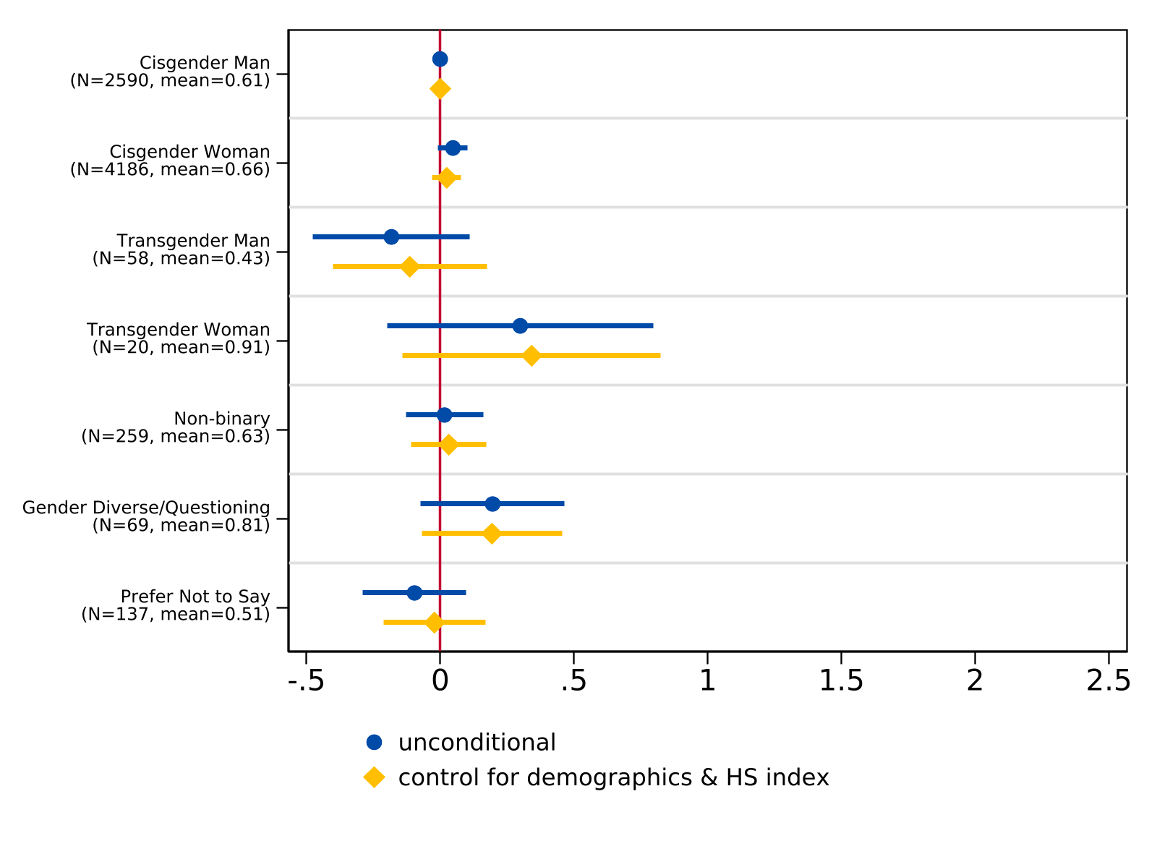
Note. We estimate regression models with gender indicators for an unconditional model (n = 7,319) and include race/ethnicity indicators, parental education indicators, and a constructed high school experience index as covariates for the specification with control variables (n = 7,276). The lines indicate 95 percent confidence intervals while the sample frequency and mean for each gender identity are reported in parentheses. The vertical line at 0 represents the coefficient for the reference group (cisgender man).
We find a similar pattern when examining college concerns by sexual orientation. All non-heterosexual groups report significantly higher levels of general worries compared to straight/heterosexual students (Figure X). The magnitude of these differences is fairly consistent across sexual orientation categories, with point estimates ranging from roughly 0.5 to 1.0 units above straight/heterosexual students. Other/queer/questioning students report the highest level of general worries (mean = 4.58), though the confidence interval is wider due to smaller sample size. These differences remain statistically significant after controlling for demographics and high school experience, though the estimates are somewhat attenuated.
Worries about discrimination also differ significantly by sexual orientation (Figure X). All non-heterosexual groups report higher levels of worry about discrimination relative to straight/heterosexual students (mean = -1.39). Among sexual minority students, asexual/aromantic/demisexual and other/queer/questioning students report the largest differences, while bisexual/pansexual/omnisexual students report somewhat smaller but still significant differences. These estimates are robust to the inclusion of demographic controls and the high school experience index.
As with gender identity, worries about financial burdens do not differ meaningfully by sexual orientation (Figure X). Point estimates are close to zero for most groups and confidence intervals generally overlap with the reference line, suggesting that financial concerns about college are not strongly associated with sexual orientation.

Figure X
Regression of General College Worries on Sexual Orientation

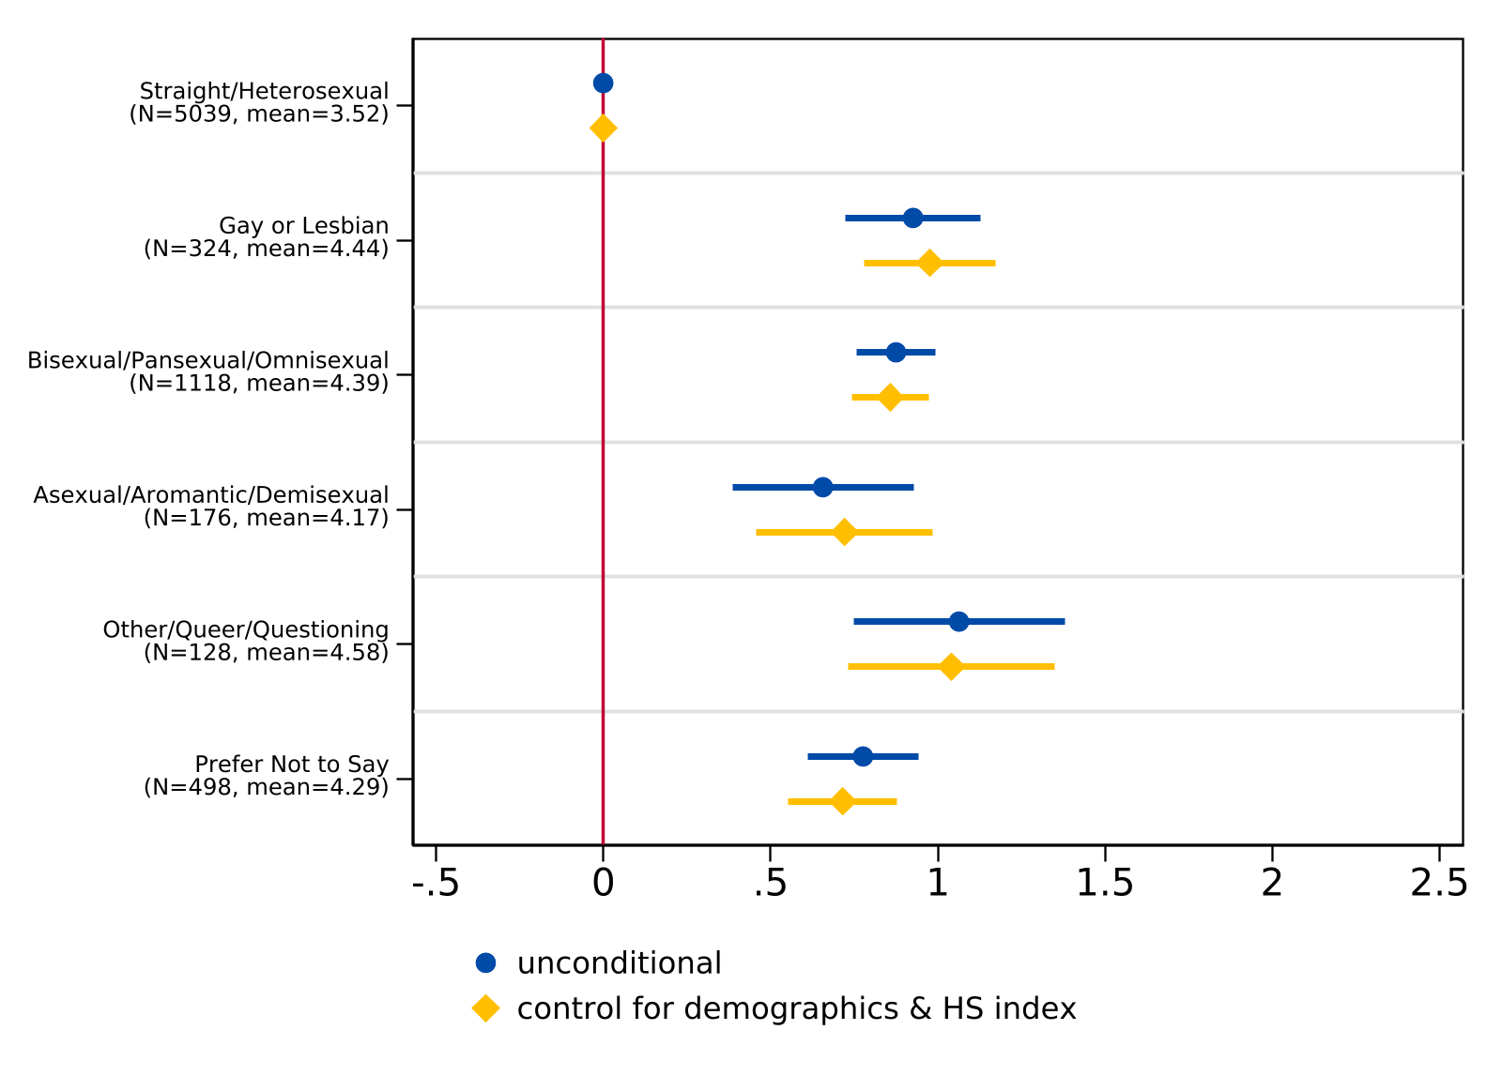
Note. For the unconditional model, n = 7,283. For the model controlling for demographics (race/ethnicity and parental level of education), n = 7,263. The lines indicate 95 percent confidence intervals while the sample frequency and mean index of each sexual orientation are reported in parentheses. The vertical line at 0 represents the coefficient for the reference group (straight/heterosexual).

Figure X
Regression of College Worries about Discrimination on Sexual Orientation
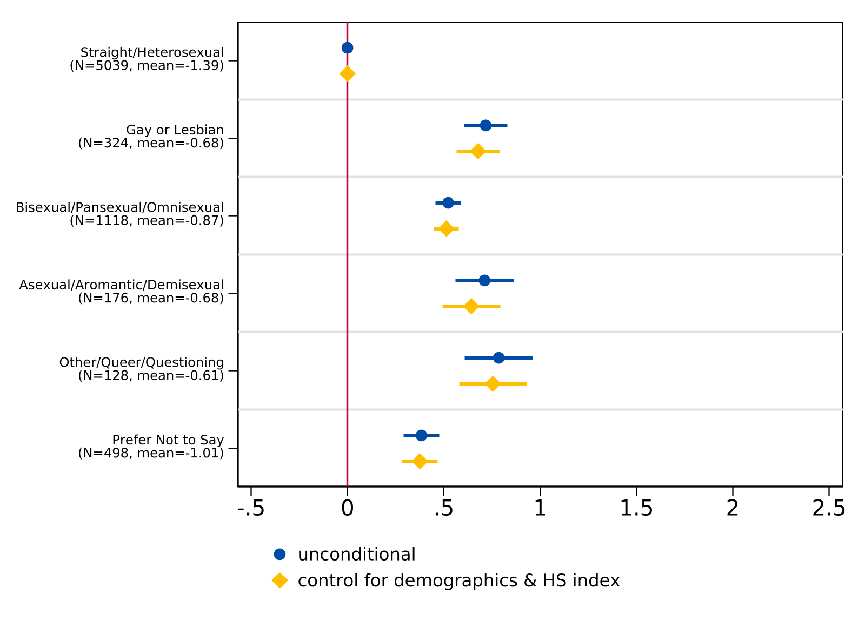
Note. For the unconditional model, n = 7,283. For the model controlling for demographics (race/ethnicity and parental level of education), n = 7,263. The lines indicate 95 percent confidence intervals while the sample frequency and mean index of each sexual orientation are reported in parentheses. The vertical line at 0 represents the coefficient for the reference group (straight/heterosexual).

Figure X
Regression of College about Financial Burdens on Sexual Orientation
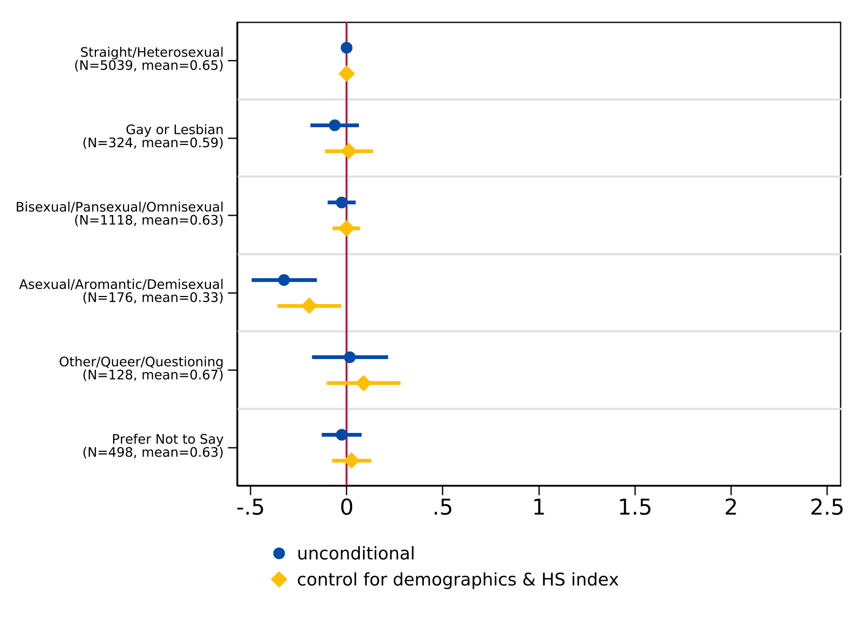
Note. For the unconditional model, n = 7,283. For the model controlling for demographics (race/ethnicity and parental level of education), n = 7,263. The lines indicate 95 percent confidence intervals while the sample frequency and mean index of each sexual orientation are reported in parentheses. The vertical line at 0 represents the coefficient for the reference group (straight/heterosexual).

Post-secondary Education Plans
We first explore patterns in academic plans across gender identity, including college program type, intended field of study, and the highest degree students planned to pursue. Findings indicate that most students planned to enroll in a four-year college compared to a two-year college across gender identity (Figure 7); however, more transgender and nonbinary students planned to enroll in four-year colleges compared to their cisgender peers. Conversely, students that identified as gender diverse or questioning intended to enroll in a two-year or four-year college at nearly similar rates (49.3% and 50.7%, respectively).
Figure 7
Plans for Two- or Four- Year College Enrollment Among 12th Grade Participants (n = 7,522) by Gender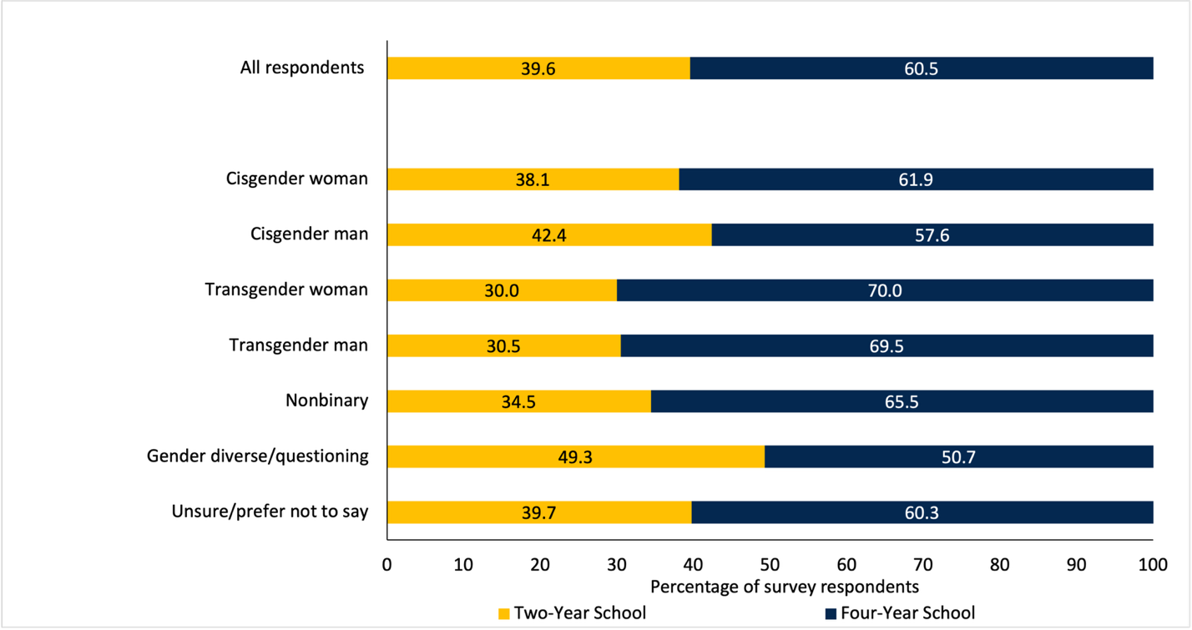

Differences also emerged in students’ intended field of study (Table 4). Overall, most students planned to study natural sciences (16.3%), engineering (16.2%), and health sciences (14.8%), including trans and gender expansive students. In this case, these students often selected these majors at higher rates than their peers. For example, transgender women planned to study engineering at nearly 9 percentage points above the rate overall. Trans and gender expansive students were also more likely to pursue humanities and the arts, as gender diverse students (31.0%), transgender men (28.8%), nonbinary students (25.5%), and transgender women (25.0%) all indicated this field at much higher rates than the sample overall (11.4%). Additionally, fewer trans and gender expansive students were undecided about their major (8.4%) compared to their cisgender peers (15.5%).
Table 4
Intended Field of Study by Gender Identity (n = 7,499)
 | Business | Engineering | Natural sciences | Social sciences | Humanities and arts | Health sciences | Education | Applied sciences | Public service | Undecided | N
All respondents | 10.0 | 16.2 | 16.3 | 12.3 | 11.4 | 14.8 | 3.5 | 3.4 | 4.8 | 7.5 | 7,499
Cisgender man | 12.1 | 30.0 | 12.2 | 7.9 | 8.9 | 8.0 | 1.4 | 7.0 | 4.3 | 8.4 | 2,662
Cisgender woman | 9.6 | 7.8 | 18.4 | 14.7 | 11.2 | 19.9 | 4.9 | 1.2 | 5.3 | 7.1 | 4280
Transgender man | 1.7 | 13.6 | 22.0 | 15.3 | 28.8 | 6.8 | 5.1 | 1.7 | 1.7 | 3.4 | 59
Transgender woman | 10.0 | 25.0 | 10.0 | 10.0 | 25.0 | 0.0 | 0.0 | 15.0 | 0.0 | 5.0 | 20
Nonbinary | 3.0 | 12.0 | 19.9 | 15.4 | 25.5 | 7.9 | 3.0 | 3.4 | 3.4 | 6.7 | 267
Gender diverse/  questioning | 1.4 | 9.9 | 19.7 | 16.9 | 31.0 | 8.5 | 1.4 | 1.4 | 5.6 | 4.2 | 71
Prefer not to say | 5.0 | 19.3 | 18.6 | 12.9 | 17.9 | 9.3 | 2.9 | 2.1 | 3.6 | 8.6 | 140
N | 749 | 1211 | 1220 | 920 | 852 | 1106 | 262 | 255 | 360 | 564 | 7,499
Note. Each cell represents the row percentage.
Students also indicated the highest degree they planned to complete (Figure 8). Across all respondents, over half (54.9%) planned to earn an advanced degree. Additionally, we find that more trans and gender expansive students indicated plans to earn a master’s or doctorate at higher rates compared to cisgender students. Among transgender women, of the 55.0% that planned to complete an advanced degree, 72.7% intended to earn a master’s degree—higher than any other gender identity we surveyed. Comparatively, transgender women, gender diverse/questioning students, and cisgender men were more likely to pursue an associate or vocational degree compared to other students, although transgender women and cisgender men appear to be outliers overall.
Figure 8
Plans for Degree Completion (n = 7,497)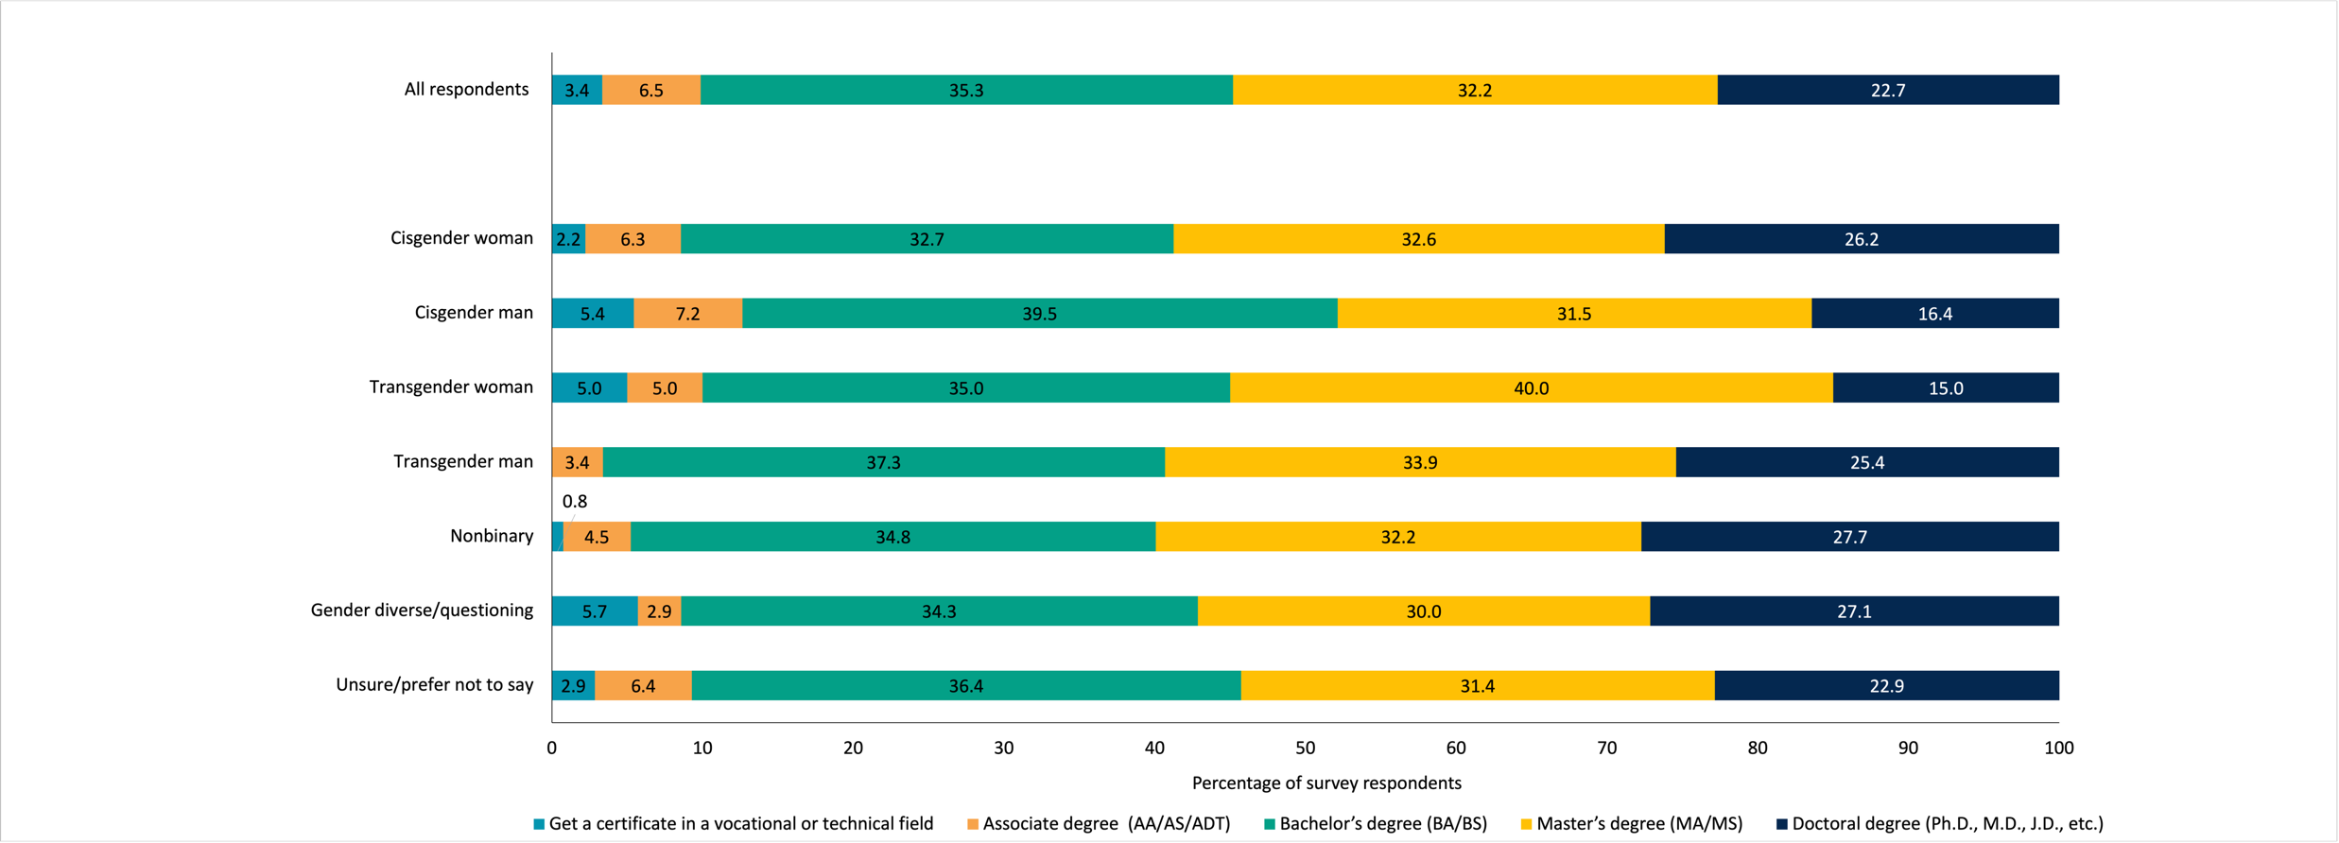
Note.

To examine whether descriptive differences in academic plans persist after accounting for student demographics, we estimated logit models for intent to attend a four-year college and ordered logit models for highest degree aspirations, separately by gender identity and sexual orientation. We report odds ratios, where values greater than one indicate higher odds relative to the reference category. See Appendix H for regression tables with raw coefficient estimates. We also report the predicted probabilities from the ordered logit models as stacked bar charts evaluated at sample means in Appendix I.
For four-year enrollment by gender identity (Table X), nonbinary students were significantly more likely than cisgender men to plan to attend a four-year institution, and this difference was robust to the inclusion of demographic controls. Cisgender women were also significantly more likely to plan to attend a four-year college in both specifications. The odds ratio for gender diverse/questioning students was less than one in both specifications, consistent with the descriptive finding that this group was roughly equally split between two- and four-year enrollment plans. For the smallest gender identity subgroups — transgender men (n = 59) and transgender women (n = 20) — the odds ratios were greater than one, but estimates are imprecise due to limited sample sizes; therefore, we refrain from drawing conclusions about four-year enrollment for these categories based on the regression estimates alone and instead direct readers to the descriptive results reported in Figure X.
For highest degree aspirations by gender identity (Table X), we find that cisgender women had 1.63 times the odds of aspiring to a higher degree category compared to cisgender men in the unconditional model (OR = 1.63, 95% CI [1.49, 1.78]), increasing slightly to 1.73 with demographic controls. Similarly, nonbinary students had significantly higher degree aspirations (OR = 1.80, 95% CI [1.43, 2.26]), and transgender men also had significantly higher odds (OR = 1.74, 95% CI [1.10, 2.75]). Gender diverse/questioning students had elevated odds that were statistically significant in the unconditional model (OR = 1.58, 95% CI [1.02, 2.45]) but attenuated to marginal significance with controls. The odds ratio for transgender women was not statistically significant, likely due to the small sample size.
Results by sexual orientation were broadly consistent. For four-year enrollment (Table X), gay or lesbian students and bisexual/pansexual/omnisexual students were significantly more likely to plan to attend a four-year college, and these differences persisted after controlling for demographics. The odds ratios for asexual/aromantic/demisexual and other/queer/questioning students were greater than one and significant in the unconditional models but attenuated and no longer statistically significant with the inclusion of demographic controls, suggesting that some of the descriptive differences for these groups may reflect compositional variation in race/ethnicity or parental education.

Table X
Logit Models: Intent to Attend 4-Year College (Odds Ratios), by Gender Identity

 | (1) | (2)
Cisgender Woman | 1.196*** | 1.282***
 | [1.084,1.319] | [1.154,1.424]
Transgender Man | 1.676* | 1.481
 | [0.958,2.933] | [0.816,2.686]
Transgender Woman | 1.717 | 1.516
 | [0.658,4.482] | [0.549,4.190]
Non-binary | 1.400** | 1.341**
 | [1.075,1.822] | [1.015,1.771]
Gender Diverse/Questioning | 0.757 | 0.681
 | [0.472,1.213] | [0.412,1.125]
Prefer Not to Say | 1.117 | 1.100
 | [0.790,1.579] | [0.754,1.603]
Observations | 7522 | 7498
Demographic Controls | No | Yes
Exponentiated coefficients; 95% confidence intervals in brackets
* p < 0.10, ** p < 0.05, *** p < 0.01

Table X
Logit Models: Intent to Attend 4-Year College (Odds Ratios), by Sexual Orientation

 | (1) | (2) | (3)
Gay or Lesbian | 1.692*** | 1.498*** | 1.496***
 | [1.327,2.156] | [1.159,1.935] | [1.157,1.935]
Bisexual/Pansexual/Omnisexual | 1.410*** | 1.347*** | 1.264***
 | [1.233,1.614] | [1.169,1.553] | [1.093,1.462]
Asexual/Aromantic/Demisexual | 1.608*** | 1.190 | 1.116
 | [1.168,2.213] | [0.845,1.675] | [0.790,1.575]
Other/Queer/Questioning | 1.413* | 1.186 | 1.121
 | [0.979,2.039] | [0.803,1.750] | [0.758,1.657]
Prefer Not to Say | 1.001 | 0.899 | 0.863
 | [0.832,1.204] | [0.737,1.096] | [0.707,1.054]
Observations | 7481 | 7456 | 7446
Demographic Controls | No | Yes | Yes
Assigned Sex at Birth | No | No | Yes
Exponentiated coefficients; 95% confidence intervals in brackets
* p < 0.10, ** p < 0.05, *** p < 0.01

For degree aspirations (Tables X and X), ordered logit results reported as odds ratios indicate that nonbinary students had significantly higher degree aspirations than cisgender men (OR = 1.80, 95% CI [1.43, 2.26]), with the largest and most precisely estimated odds ratio among the trans and gender expansive categories; this difference remained robust with demographic controls (OR = 1.83, 95% CI [1.45, 2.30]). Transgender men also reported significantly higher degree aspirations in both the unconditional (OR = 1.74, 95% CI [1.10, 2.75]) and controlled (OR = 1.66, 95% CI [1.03, 2.67]) models. Gender diverse/questioning students had 1.58 times the odds of aspiring to a higher degree category in the unconditional model (95% CI [1.02, 2.45]), though this attenuated to marginal significance with demographic controls (OR = 1.54, 95% CI [0.99, 2.41]). Cisgender women had significantly higher degree aspirations across both specifications (OR = 1.63 unconditional; OR = 1.73 with controls). For transgender women, the very small sample size (n = 20) produced estimates that were too imprecise to support meaningful inference (OR = 1.19, 95% CI [0.55, 2.61]); while the descriptive patterns suggest that transgender students as a group report lower rates of certificate and associate degree aspirations and comparable or higher rates of master's degree aspirations relative to cisgender men, the regression models lack the statistical power to confirm these patterns for this subgroup individually. We therefore direct readers to the descriptive results in Figure 2 rather than interpret these coefficients substantively. In terms of sexual orientation, gay or lesbian students (OR = 1.53, 95% CI [1.25, 1.87]) and bisexual/pansexual/omnisexual students (OR = 1.64, 95% CI [1.45, 1.84]) consistently reported higher degree aspirations across both specifications. The odds ratios for asexual/aromantic/demisexual students (OR = 1.52, 95% CI [1.17, 1.98]) and other/queer/questioning students (OR = 1.44, 95% CI [1.06, 1.96]) were significant in the unconditional models but attenuated and no longer statistically significant with the inclusion of demographic controls, suggesting that some of these descriptive differences may reflect compositional variation in race/ethnicity or parental education.

Table X
Ordered Logit Models: Highest Degree Plans (Odds Ratios) , by Gender Identity

 | (1) | (2)
Cisgender Woman | 1.627*** | 1.734***
 | [1.489,1.777] | [1.585,1.896]
Transgender Man | 1.738** | 1.661**
 | [1.098,2.750] | [1.032,2.674]
Transgender Woman | 1.194 | 1.050
 | [0.548,2.605] | [0.477,2.311]
Non-binary | 1.798*** | 1.829***
 | [1.432,2.257] | [1.451,2.304]
Gender Diverse/Questioning | 1.584** | 1.541*
 | [1.023,2.453] | [0.985,2.411]
Prefer Not to Say | 1.368** | 1.296
 | [1.005,1.863] | [0.945,1.778]
Observations | 7497 | 7475
Demographic Controls | No | Yes
Exponentiated coefficients; 95% confidence intervals in brackets
* p < 0.10, ** p < 0.05, *** p < 0.01

Table X

Ordered Logit Models: Highest Degree Plans (Odds Ratios), by Sexual Orientation

 | (1) | (2) | (3)
Gay or Lesbian | 1.527*** | 1.388*** | 1.353***
 | [1.250,1.867] | [1.130,1.704] | [1.101,1.663]
Bisexual/Pansexual/Omnisexual | 1.636*** | 1.587*** | 1.386***
 | [1.454,1.840] | [1.408,1.788] | [1.226,1.566]
Asexual/Aromantic/Demisexual | 1.522*** | 1.251 | 1.079
 | [1.168,1.983] | [0.955,1.638] | [0.822,1.416]
Other/Queer/Questioning | 1.440** | 1.293 | 1.117
 | [1.056,1.963] | [0.941,1.777] | [0.811,1.537]
Prefer Not to Say | 1.162* | 1.049 | 0.957
 | [0.986,1.370] | [0.887,1.240] | [0.808,1.132]
Observations | 7456 | 7433 | 7423
Demographic Controls | No | Yes | Yes
Assigned Sex at Birth | No | No | Yes
Exponentiated coefficients; 95% confidence intervals in brackets
* p < 0.10, ** p < 0.05, *** p < 0.01

Overall, these regression results confirm that many LGBTQ+ students — particularly nonbinary students, gay or lesbian students, and bisexual/pansexual/omnisexual students — maintain high educational aspirations that are not explained by demographic composition alone. At the same time, the limited statistical power for the smallest gender identity subgroups highlights a recurring challenge in quantitative research on transgender populations and reinforces the need for larger, targeted data collection efforts that can support more precise inference for these communities.

Qualitative Findings
The survey also asked respondents two open-ended questions: (1) “What do you think is the biggest challenge you’ll face in college?” and (2) “What are you most excited about for college?” Although a full qualitative analysis of these data is beyond the scope of this paper, we report some of the social concerns and hopes raised by transgender, nonbinary, and gender diverse/questioning students.

Social Challenges and Discrimination
Nearly one-quarter of trans and gender expansive students identified social challenges as a concern, with many worried about making new friends or whether they would make friends at all. A nonbinary student described, “Making friends has been a challenge for me in the past when I had to go somewhere new and didn’t know anyone, so it might take a little while to get close with people.” Transgender students also expressed concerns over finding community once they entered college, including worries they may not fit in, or may feel alone or overwhelmed in a new social environment. These worries also included fears of discrimination; multiple students noted concerns about transphobia, coming out to others, and seeing kids from their high school. Moreover, the most intense social concern came from one nonbinary student who shared: “I could die from hate crimes.”

Finding Friends and Community
In contrast, over 36% of trans and gender expansive students were excited about the social aspects of college, as students anticipated meeting new people and building new friendships even despite some apprehension. One nonbinary student expressed, “I will be making friends on my own, which is scary, but something to look forward to.” Several students looked forward to finding community, with one gender diverse student writing: “[I am excited] to be able to build a community for myself where I truly feel that I belong.” Additionally, students anticipated meeting other students similar to themselves. One nonbinary student explained, “I’m most excited about the friendships I will form with people who share the same mindset as me.” Students also wanted to meet people who shared their academic interests. As one gender diverse/questioning student noted: “I’m really excited to be part of a supportive and engaging community… [and] excited to be around people with a similar drive for learning and an appreciation of education.”
Several students were also excited to attend a college where they could access gender-affirming healthcare and housing. One gender diverse/questioning student mentioned, “I’m also going to be downtown for college and I know that the college I’m going to is very LGBTQ+ friendly.” Another nonbinary student explained, “I’m also looking forward to receiving certain medical treatment at my college’s health center that I currently don’t have access to.”
Some trans and gender expansive students also looked forward to the opportunity to leave their home environment. Students described a desire to “[get] away from home and a community that I was almost constantly harassed in,” “leave my abusive household,” and “be away from home… [and] finally hav[e] my own autonomy.” One trans woman added that leaving home and entering college explicitly offered “the ability to transition my gender identity, as my parents are opposed to it.”

Limitations
One limitation to consider in this work is that our sample is restricted to students that indicated their plans to enroll in college in the fall after their senior year. In this case, our results uniquely speak to a group of students that made it to 12th grade and made the decision to explore college. As such, results do not include students who dropped out prior to 12th grade, had other plans, or for whom college seemed out of reach—a population future research should examine in more detail, particularly for LGBTQ+ students. We also wish to note that students’ plans can change—some students may not enroll in college after the survey was administered, underscoring that expectations to enroll do not always lead to enrollment (Klasik et al., 2025). Thus, these results reflect a unique sample of intended college-goers captured at one point in time. Future research on high school completion as well as college enrollment and retention by gender identity is needed.

Discussion and Conclusion
The transition from high school to college is an important one, and the high school experiences of LGBTQ+ students can influence their educational expectations and later attainment. Results revealed a statistically significant difference between the experiences of cisgender students compared to trans and gender expansive students, who reported less positive high school experiences overall. This may be associated with gender-related victimization, which transgender and gender expansive students often experience in high school (Hatchel et al., 2018; McBride, 2021). This is consistent with our findings on bullying, in which only 35% of transgender students and 54% of nonbinary and gender diverse/questioning students reported no bullying in the past year, compared to 84% of cisgender men. Moreover, among those who were bullied, 100% of transgender students and 88% of nonbinary and gender diverse/questioning students attributed the bullying to their gender identity or sexual orientation, suggesting that the less positive high school experiences reported by these students are connected to identity-based victimization. Given these experiences, we examined students’ perceptions ahead of college enrollment as experiences can play a role in students’ expectations for college. Overall, trans and gender expansive students worried more about discrimination compared to cisgender students. This increased concern then likely played a role in how trans and gender expansive students thought about where to enroll, what to study, and how they would navigate college. Expand… ‘The energy that LGBTQ+ students expend navigating and trying to avoid adverse experiences (including remaining closeted) detracts from the quality of their educational experience and ability to create community.’
However, despite (or because of) these worries, students still planned to pursue postsecondary schooling—in fact, trans and gender expansive students planned to pursue advanced degrees at higher rates than their peers. While this differs from previous research (Feldman et al., 2022; Sansone, 2019; Wilkinson et al., 2021), the schooling experiences of transgender and gender expansive students in our sample may include supports (whether at school or at home) potentially absent to students documented in other studies. For example, students may have had access to resources that can promote the well-being of trans and gender expansive students, such as social support from peers, family, and the community; school-inclusive policies; and extracurricular activities, among others (Fernandes et al., 2023).
These findings take on added significance in the current policy landscape. Since the collection of our data in 2023, the federal policy environment for LGBTQ+ students has shifted considerably. For example, Executive Order 14168, titled “Defending Women from Gender Ideology Extremism and Restoring Biological Truth to the Federal Government,” was signed on January 20, 2025, withdrawing federal recognition of transgender identities and requiring federal agencies to define sex as an immutable binary determined at conception. Subsequent executive actions have further restricted Title IX protections for transgender students, banned transgender individuals from military service, and sought to curtail access to gender-affirming care for minors (CITE). At the same time, California has continued to strengthen state-level protections for LGBTQ+ youth (CITE). This divergence underscores the importance of state-level data and state-level action. Our results suggest that even within California’s comparatively protective policy environment, trans and gender expansive students experienced significant disparities in high school climate and identity-based victimization at the time of our survey. As federal protections for transgender students are rolled back, the role of state and local policy in addressing these disparities becomes even more critical.
Our findings carry several implications for California education policy. First, the stark disparities in bullying rates and identity-based victimization documented in this study suggest that generic anti-bullying programs may be insufficient to address the experiences of trans and gender expansive students. That 100% of bullied transgender students (n = 42) attributed their victimization to their gender identity or sexual orientation points to the need for targeted interventions that specifically address identity-based harassment, including expanded support for gender-sexuality alliances (GSAs) and professional development for school staff on LGBTQ+ student needs. California’s Seth’s Law (AB 9, 2012) already requires schools to adopt anti-bullying policies that enumerate sexual orientation and gender identity as protected categories; however, our findings indicate that substantial identity-based victimization persists despite this legal framework, suggesting that districts may benefit from additional resources and accountability mechanisms to ensure these policies are actively implemented.
Second, the patterns documented here—where trans and gender expansive students report less positive high school experiences and elevated rates of identity-based bullying yet maintain educational aspirations—are consistent with the social ecological theory of resilience framing this study (Ungar, 2011, 2012). Policymakers and institutions can build on this by ensuring that the transition from high school to college is supported with resources that address the specific concerns these students reported, including worries about discrimination, finding community, and accessing gender-affirming services. This includes investments in bridge programs, mentoring, and campus resources that are responsive to the needs of incoming LGBTQ+ students.
Third, our study highlights the critical need for California to continue collecting and disaggregating data by gender identity and sexual orientation in statewide surveys and school climate assessments. The richness of the data collected in partnership with the California Student Aid Commission allowed us to identify disparities that would be invisible in datasets that treat LGBTQ+ students as a monolithic group or that omit gender identity measures entirely. As the state considers how to monitor school climate and student well-being going forward, this level of detail will be essential to understanding and addressing the needs of this population. However, we also recognize that in the current political climate, students may have legitimate concerns about disclosing their identities in institutional surveys. Efforts to build on this kind of evidence base will need to balance the analytic power of detailed identity data with robust protections for student privacy and confidentiality. More broadly, our findings underscore the importance of California’s continued commitment to fostering safe, affirming educational environments — and to ensuring that all students, regardless of gender identity or sexual orientation, are supported in realizing their educational aspirations. As California approaches a new chapter of its education policy, we hope these findings will offer a foundation for evidence-based action on behalf of some of the state’s most vulnerable students.

References
Alvarado, S. E., & An, B. P. (2015). Race, friends, and college readiness: Evidence from the high school longitudinal study. Race and Social Problems, 7, 150–167. https://doi.org/ 10.1007/s12552-015-9146-5
Aragon, S. R., Poteat, V. P., Espelage, D. L., & Koenig, B. W. (2014). The influence of peer victimization on educational outcomes for LGBTQ and non-LGBTQ high school students. Journal of LGBT Youth, 11(1), 1–19. https://doi.org/10.1080/ 19361653.2014.840761
Austin, G., Hanson, T., Bala, N., & Zheng, C. (2023). Student engagement and well-being in California, 2019–21: Results of the Eighteenth Biennial State California Healthy Kids Survey, grades 7, 9, and 11. WestEd. https://data.calschls.org/resources/18th_ Biennial_State_1921.pdf
Badgett, M. V., Goldberg, N., Conron, K., & Gates, G. (2009, November). Best practices for asking questions about sexual orientation on surveys. The Williams Institute. https://williamsinstitute.law.ucla.edu/wp-content/uploads/Best-Practices-SO-Surveys-Nov-2009.pdf
Bandura, A. (1981). Self-referent thought: A developmental analysis of self-efficacy. In J.H. Flavell & L. Ross (Eds.), Social cognitive development: Frontiers and possible futures (pp. 200–239). Cambridge, England: Cambridge University Press.
Beemyn, G. (2022). The changing nature of gender in the 21st century: How trans and nonbinary students applying to college today self-identify. Campus Pride. https://www.campuspride.org/wp-content/uploads/CampusPride_ChangingNature ofGender21stCentury.pdf
Bourdieu, P. (1986). The forms of capital. In J.G. Richardson (Ed.), Handbook of theory and research for the sociology of education, (pp. 241–258). New York, NY: Greenwood.
Callis, A. S. (2014). Bisexual, pansexual, queer: Non-binary identities and the sexual borderlands. Sexualities, 17(1-2), 63–80. https://doi.org/10.1177/1363460713511094
Casillas, A., Robbins, S., Allen, J., Kuo, Y. L., Hanson, M. A., & Schmeiser, C. (2012). Predicting early academic failure in high school from prior academic achievement, psychosocial characteristics, and behavior. Journal of Educational Psychology, 104(2), 407–420. https://doi.org/10.1037/a0027180
Choi, K. H., Kelly Raley, R., Muller, C., & Riegle‐Crumb, C. (2008). Class composition: Socioeconomic characteristics of coursemates and college enrollment. Social Science Quarterly, 89(4), 846–866. https://doi.org/10.1111/j.1540-6237.2008.00587.x
Day, J. K., Perez-Brumer, A., & Russell, S.T. (2018). Safe schools? Transgender youth's school experiences and perceptions of school climate. Journal of Youth and Adolescence, 47(8), 1731–1742. https://doi.org/10.1007/s10964-018-0866-x
DesJardins, S. L., Toutkoushian, R. K., Hossler, D., & Chen, J. (2019). Time may change me: Examining how aspirations for college evolve during high school. The Review of Higher Education, 43(1), 263–294. https://doi.org/10.1353/rhe.2019.0096
DiFulvio, G. T. (2011). Sexual minority youth, social connection and resilience: From personal struggle to collective identity. Social Science & Medicine, 72(10), 1611–1617. https://doi.org/10.1016/j.socscimed.2011.02.045
Eccles, J. S., & Roeser, R. W. (2011). Schools as developmental contexts during adolescence. Journal of Research on Adolescence, 21(1), 225–241. https://doi.org/10.1111/j.1532-7795.2010.00725.x
Feldman, S., Watson, R. J., & Gallik, C. (2022). College aspirations, gender sexuality alliances, and teacher support among diverse LGBTQ youth. Educational Review, 74(2), 281–297. https://doi.org/10.1080/00131911.2020.1816907
Fletcher, J. M. (2015). Social interactions and college enrollment: A combined school fixed effects/instrumental variables approach. Social Science Research, 52, 494–507. https://doi.org/10.1016/j.ssresearch.2015.03.004
Forbes, T. D. (2022). Queer-free majors?: LGBTQ+ college students’ accounts of chilly and warm academic disciplines. Journal of LGBT Youth, 19(3), 330–349. https://doi.org/10.1080/19361653.2020.1813673
Fotopoulou, A. (2012). Intersectionality queer studies and hybridity: Methodological frameworks for social research. Journal of International Women's Studies, 13(2), 19–32. https://vc.bridgew.edu/jiws/vol13/iss2/3
Galupo, M. P., Mitchell, R. C., & Davis, K. S. (2015). Sexual minority self-identification: Multiple identities and complexity. Psychology of Sexual Orientation and Gender Diversity, 2(4), 355–364. https://doi.org/10.1037/sgd0000131
Goldberg, A. E., Beemyn, G., & Smith, J. Z. (2019). What is needed, what is valued: Trans students’ perspectives on trans-inclusive policies and practices in higher education. Journal of Educational and Psychological Consultation, 29(1), 27–67. https://doi.org/10.1080/10474412.2018.1480376
Goldberg, A. E., & Kuvalanka, K. A. (2018). Navigating identity development and community belonging when “there are only two boxes to check”: An exploratory study of nonbinary, trans college students. Journal of LGBT Youth, 15(2), 106–131. https://doi.org/10.1080/19361653.2018.1429979
Gong, H. J., & Toutkoushian, R. K. (2024). High school students’ expectations and college aspirations: Causes and consequences. Educational Policy, 38(1), 254–28. https://doi.org/10.1177/08959048231153600
Hammack, P. L., Hughes, S. D., Atwood, J. M., Cohen, E. M., & Clark, R. C. (2022). Gender and sexual identity in adolescence: A mixed-methods study of labeling in diverse community settings. Journal of Adolescent Research, 37(2), 167–220. https://doi.org/10.1177/ 07435584211000315
Hatchel, T., Valido, A., De Pedro, K. T., Huang, Y., & Espelage, D. L. (2018). Minority stress among transgender adolescents: The role of peer victimization, school belonging, and ethnicity. Journal of Child and Family Studies, 28(9), 2467–2476. https://doi.org/ 10.1007/s10826-018-1168-3
Hattie, J. (2009). Visible learning: A synthesis of over 800 meta-analyses relating to achievement. Corwin.
Herman, J. L. (2014, September). Best practices for asking questions to identify transgender and other gender minority respondents on population-based surveys. The Williams Institute. https://williamsinstitute.law.ucla.edu/wp-content/uploads/Survey-Measures-Trans-GenIUSS-Sep-2014.pdf
Hershbein, B. & Kearney, M. (2014). Major decisions: What graduates earn over their lifetimes. The Hamilton Project. http://www.hamiltonproject.org/assets/legacy/files/downloads_ and_links/Major_Decisions_Lifetime__Earnings_by_Major.pdf
Hill, L. D. (2008). School strategies and the ‘college-linking’ process: Reconsidering the effects of high schools on college enrollment. Sociology of Education, 81(1), 53–76. https://doi.org/10.1177/003804070808100103
Hunter, J., Butler, C., & Cooper, K. (2021). Gender minority stress in trans and gender diverse adolescents and young people. Clinical Child Psychology and Psychiatry, 26(4), 1182–1195. https://doi.org/10.1177/13591045211033187
Hurtt, A., Kurlaender, M., Sun, C., Weber, K., & Zhou, B. (2026). The transition to college for LGBTQ+ youth: High school experiences and college expectations. Forthcoming.
Kersey, E. & Voigt, M. (2021). Finding community and overcoming barriers: Experiences of queer and transgender postsecondary students in mathematics and other STEM fields.” Mathematics Education Research Journal, 33(4), 733–756. https://doi.org/10.1007/s13394-020-00356-5
Kosciw, J. G., Clark, C. M., & Menard, L. (2022). The 2021 national school climate survey: The experiences of LGBTQ+ youth in our nation’s schools. New York: GLSEN. https://www.glsen.org/sites/default/files/2022-10/NSCS-2021-Full-Report.pdf
Kurlaender, M., Reed, S., & Hurtt, A. (2019, August). Improving college readiness: A research summary and implications for practice. Policy Analysis for California Education, PACE. https://edpolicyinca.org/sites/default/files/R_Kurlaender_Aug19_01.pdf
Lazowski, R. A., & Hulleman, C. S. (2016). Motivation interventions in education: A meta-analytic review. Review of Educational Research, 86(2), 602–640. https://doi.org/10.3102/ 0034654315617832
Linley, J. L., Renn, K. A., & Woodford, M. R. (2018). Examining the ecological systems of LGBTQ STEM majors. Journal of Women and Minorities in Science and Engineering, 24(1), 1–16. https://doi.org/10.1615/jwomenminorscieneng.2017018836
Luh, H. J., deLeyer-Tiarks, J., Wojcik, H., & Mandracchia, F. (2023). Preparing LGBTQ youth for the high school to college transition: A multidimensional approach. Journal of LGBT Youth, 1–20. https://doi.org/10.1080/19361653.2023.2264830
Ma, J., Pender, M., & Welch, M. (2019). Education pays 2019: The benefits of higher education for individuals and society. Trends in Higher Education Series. College Board. https://research.collegeboard.org/media/pdf/education-pays-2019-full-report.pdf
Marine, S. B., & Nicolazzo, Z. (2014). Names that matter: Exploring the tensions of campus LGBTQ centers and trans* inclusion. Journal of Diversity in Higher Education, 7(4), 265–281. https://doi.org/10.1037/a0037990
McBride, R. S. (2021). A literature review of the secondary school experiences of trans youth. Journal of LGBT Youth, 18(2), 103–134. https://doi.org/10.1080/19361653. 2020.1727815
Means, B., Wang, H., Young, V., Peters, V. L., & Lynch, S. J. (2016). STEM-focused high schools as a strategy for enhancing readiness for postsecondary STEM programs. Journal of Research in Science Teaching, 53(5), 709–736. https://doi.org/10.1002/tea.21313
Meyer, I. H. (2015). Resilience in the study of minority stress and health of sexual and gender minorities. Psychology of Sexual Orientation and Gender Diversity, 2(3), 209–213. https://doi.org/10.1037/sgd0000132
Mittleman, J. (2022). Intersecting the academic gender gap: The education of lesbian, gay, and bisexual America. American Sociological Review, 87(2), 303-335. https://doi.org/10.1177/00031224221075776
Morgan, E. M. (2013). Contemporary issues in sexual orientation and identity development in emerging adulthood. Emerging Adulthood, 1(1), 52–66. https://doi.org/10.1177/ 2167696812469187
Morton, T. R., Ramirez, N. A., Meece, J. L., Demetriou, C., & Panter, A. T. (2018). Perceived barriers, anxieties, and fears in prospective college students from rural high schools. High School Journal, 101(3), 155–176. https://www.jstor.org/stable/90024241
O’Neill, K. K. & Conron, K. J. (co-first authors), Goldberg, A. E., & Guardado, R. (2022). The experiences of LGBTQ people in four-year colleges and graduate programs: Findings from a national probability survey. The Williams Institute. https://williamsinstitute.law.ucla.edu/wp-content/uploads/LGBTQ-College-Grad-School-May-2022.pdf
Olson, J. (2017). Moving up, feeling down: Socioemotional health during the transition into college. Longitudinal and Life Course Studies, 8(3), 3. http://dx.doi.org/10.14301/ llcs.v8i3.419
Osterman, K. F. (2000). Students’ need for belonging in the school community. Review of Educational Research, 70(3), 323–367. https://doi.org/10.2307/1170786
Perez, N., & Farruggia, S. P. (2022). Pathways to early departure from college: The interrelated and precarious role of finances among Black and Latinx students. Race Ethnicity and Education, 25(2), 155–172. https://doi.org/10.1080/13613324.2021.1890561
Perna, L., & Titus, M. (2005). The relationship between parental involvement as social capital and college enrollment: An examination of racial/ethnic group differences. The Journal of Higher Education, 76(5), 485–518. https://doi.org/10.1080/00221546.2005.11772296
Pike, G. R., & Robbins, K. (2016). The relationships among individual characteristics, high school characteristics, and college enrollment: Using enrollment propensity as a baseline for evaluating strategic enrollment management efforts. Strategic Enrollment Management Quarterly, 3(4), 282–304. https://doi.org/10.1002/sem3.20075
Plagens, G. K. (2011). Social capital and education: Implications for student and school performance. Education and Culture, 27(1), 40–64 https://doi.org/10.1353/ eac.2011.0007
Reber, S., & Smith, E. (2023). College enrollment disparities: Understanding the role of academic preparation. Brookings. https://www.brookings.edu/wp-content/ uploads/2023/02/20230123_CCF_CollegeEnrollment_FINAL2.pdf
Riggle, E. D., Rostosky, S. S., McCants, L. E., & Pascale-Hague, D. (2011). The positive aspects of a transgender self-identification. Psychology & Sexuality, 2(2), 147–158. https://doi.org/10.1080/19419899.2010.534490
Sanlo, R. (2004). Lesbian, gay, and bisexual college students: Risk, resiliency, and retention. Journal of College Student Retention: Research, Theory and Practice, 6(1), 97–110. https://doi.org/10.2190/fh61-ve7v-hhcx-0pur
Sansone, D. (2019). LGBT students: New evidence on demographics and educational outcomes. Economics of Education Review, 73, 101933. https://doi.org/10.1016/ j.econedurev.2019.101933
Saperstein, A., & Westbrook, L. (2021). Categorical and gradational: Alternative survey measures of sex and gender. European Journal of Politics and Gender, 4(1), 11–30. https://doi.org/10.1332/251510820x15995647280686
Skobba, K., Meyers, D., & Tiller, L. (2018). Getting by and getting ahead: Social capital and transition to college among homeless and foster youth. Children and Youth Services Review, 94, 198–206. https://doi.org/10.1016/j.childyouth.2018.10.003
Stolzenberg, E. B., Aragon, M. C., Romo, E., Couch, V., McLennan, D., Eagan, M. K., & Kang, N. (2020). The American freshman: National norms fall 2019. Higher Education Research Institute, UCLA, 42. https://www.heri.ucla.edu/monographs/TheAmericanFreshman 2019.pdf
Toutkoushian, R. K., Stollberg, R. A., & Slaton, K. A. (2018). Talking ‘bout my generation: Defining “first-generation college students” in higher education research. Teachers College Record, 120(4), 1–38. https://doi.org/10.1177/016146811812000407
Ungar, M. (2011). The social ecology of resilience: Addressing contextual and cultural ambiguity of a nascent construct. American Journal of Orthopsychiatry, 81(1), 1–17. https://doi.org/10.1111/j.1939-0025.2010.01067.x
Ungar, M. (Ed.). (2012). The social ecology of resilience: A handbook of theory and practice. Springer. https://doi.org/10.1007/978-1-4614-0586-3
Uwah, C. J., McMahon, H. G., & Furlow, C. F. (2008). School belonging, educational aspirations, and academic self-efficacy among African American male high school students: Implications for school counselors. Professional School Counseling, 11(5), 296–305. https://doi.org/10.1177/2156759x0801100503
Walton, G. M., & Cohen, G. L. (2011). A brief social-belonging intervention improves academic and health outcomes of minority students. Science, 331(6023), 1447–1451. https://doi.org/10.1126/science.1198364
Watson, R. J., Wheldon, C. W., & Puhl, R. M. (2020). Evidence of diverse identities in a large national sample of sexual and gender minority adolescents. Journal of Research on Adolescence, 30(S2), 431–442. https://doi.org/10.1111/jora.12488
White, A. E., Moeller, J., Ivcevic, Z., & Brackett, M. A. (2018). Gender identity and sexual identity labels used by US high school students: A co-occurrence network analysis. Psychology of Sexual Orientation and Gender Diversity, 5(2), 243–252. https://doi.org/10.1037/ sgd0000266
Wilkinson, L., Shifrer, D., & Pearson, J. (2021). Educational outcomes of gender-diverse youth: A national population-based study. Gender & Society, 35(5), 806–837. https://doi.org/10.1177/08912432211038689

Appendix A: Additional Demographics
Table A1
Gender Identity and Sexual Orientation (n = 7,462) of 12th Grade Participants, 2023
Gender identity | Sexual orientation categories
 | Straight/  heterosexual | Gay or lesbian | Bisexual/  pansexual/  omnisexual | Asexual/  aromantic/  demisexual | Other/  queer/  questioning | Prefer not to say | Total
Cisgender man | 85.0 | 4.0 | 5.1 | 0.8 | 0.6 | 4.5 | 100.0
Cisgender woman | 68.0 | 3.0 | 17.9 | 2.3 | 1.5 | 7.3 | 100.0
Transgender man | 6.9 | 32.8 | 32.8 | 6.9 | 12.1 | 8.6 | 100.0
Transgender woman | 20.0 | 40.0 | 25.0 | 10.0 | 0.0 | 5.0 | 100.0
Nonbinary | 1.9 | 18.8 | 50.2 | 13.4 | 9.6 | 6.1 | 100.0
Gender diverse/questioning | 2.9 | 13.0 | 50.7 | 14.5 | 18.8 | 0.0 | 100.0
Prefer not to say | 7.9 | 6.5 | 33.1 | 10.1 | 4.3 | 38.1 | 100.0
Total | 69.5 | 4.4 | 15.2 | 2.4 | 1.7 | 6.8 | 100.0
Note. Each cell represents row percentages—that is, the percentage of students within each gender category of the corresponding sexual orientation.
Table A2
Demographic Characteristics of California Students Enrolled in 12th Grade in the 2022-2023 Academic Year
 | n | Percent
Panel A: Race/Ethnicity
American Indian or Alaska Native | 2,349 | 0.5
Black/African American | 23,852 | 4.9
Hispanic or Latino | 272,323 | 55.7
Pacific Islander | 2,205 | 0.5
Filipino | 13,231 | 2.7
Asian | 46,278 | 9.5
Two or More Races | 17,435 | 3.6
White/non-Hispanic | 103,787 | 21.2
Not Reported | 7,476 | 1.5
Panel B: Gender
Male | 252,390 | 51.6
Female | 235,802 | 48.2
Nonbinary | 744 | 0.2
Total | 488,936
Note. Data accessed through DataQuest (https://dq.cde.ca.gov/dataquest), which is managed by the California Department of Education.

Appendix B
High School Experience Items and Construct
 | N | Mean
Items:
How would you rate your academic performance in high school? | 7,847 | 0.7
How would you rate your social experience in high school? | 7,825 | 0.1
I feel that I belong in my high school community. | 7,711 | 0.6
Teachers and staff at my high school care about my future. | 7,711 | 1.1
I received good advising from my high school about my college plans. | 7,713 | 0.7
I feel prepared for college. | 7,709 | 0.7
Construct:
General high school experience | 7,687 | 3.8
Note. The first six rows include the Likert-scale survey items that relate to a student’s high school experience. All items range from -2 to 2, with -2 indicating a very negative experience, 2 indicating a very positive experience, and 0 indicating a neutral experience. The final row summarizes the general high school experience construct, ranging from -12 to 12, which includes all six aforementioned high school experience items. The construct is only created for students who reported non-missing values for all six high school experience items.

Appendix C: Summary Statistics of Individual High School Experience Items
High School Experience Items by Gender Identity
 | Cisgender Man | Cisgender Woman | Transgender Man | Transgender Woman | Nonbinary | Gender Diverse/  Questioning | Prefer Not to Say | Total
How would you rate your academic performance in high school?
Mean | 0.6 | 0.7 | 0.9 | 0.3 | 0.7 | 0.4 | 0.5 | 0.6
N | 2,675 | 4,289 | 59 | 20 | 267 | 71 | 141 | 7,522
How would you rate your social experience in high school?
Mean | 0.3 | 0.1 | -0.4 | -0.5 | -0.3 | -0.4 | -0.3 | 0.1
N | 2,673 | 4,286 | 59 | 20 | 267 | 71 | 140 | 7,516
I feel that I belong in my high school community.
Mean | 0.7 | 0.6 | 0.0 | 0.0 | 0.1 | -0.1 | 0.2 | 0.6
N | 2,667 | 4,280 | 59 | 20 | 267 | 71 | 139 | 7,503
Teachers and staff at my high school care about my future.
Mean | 1.1 | 1.1 | 1.0 | 1.1 | 1.0 | 0.9 | 0.9 | 1.1
N | 2,667 | 4,281 | 59 | 20 | 267 | 71 | 139 | 7,504
I received good advising from my high school about my college plans.
Mean | 0.8 | 0.7 | 0.3 | 0.8 | 0.4 | 0.4 | 0.4 | 0.7
N | 2,667 | 4,282 | 59 | 20 | 267 | 71 | 140 | 7,506
I feel prepared for college.
Mean | 0.8 | 0.6 | 0.6 | 0.9 | 0.4 | -0.1 | 0.4 | 0.6
N | 2,667 | 4,281 | 59 | 20 | 267 | 71 | 139 | 7,504

High School Experience Items by Sexual Orientation
 | Straight/Heterosexual | Gay or Lesbian | Bisexual/Pansexual/Omnisexual | Asexual/Aromantic/Demisexual | Other/Queer/Questioning | Prefer Not to Say | Total
How would you rate your academic performance in high school?
Mean | 0.6 | 0.8 | 0.6 | 1.0 | 0.7 | 0.6 | 0.6
N | 5190 | 330 | 1139 | 182 | 131 | 509 | 7847
How would you rate your social experience in high school?
Mean | 0.2 | 0.0 | -0.1 | -0.2 | -0.1 | -0.1 | 0.1
N | 5186 | 330 | 1138 | 182 | 131 | 508 | 7825
I feel that I belong in my high school community.
Mean | 0.7 | 0.4 | 0.4 | 0.4 | 0.3 | 0.3 | 0.6
N | 5174 | 330 | 1138 | 182 | 131 | 507 | 7711
Teachers and staff at my high school care about my future.
Mean | 1.1 | 1.2 | 1.1 | 1.2 | 1.2 | 1.0 | 1.1
N | 5176 | 329 | 1138 | 182 | 131 | 507 | 7711
I received good advising from my high school about my college plans.
Mean | 0.8 | 0.6 | 0.6 | 0.7 | 0.5 | 0.6 | 0.7
N | 5179 | 329 | 1138 | 182 | 130 | 507 | 7713
I feel prepared for college.
Mean | 0.7 | 0.6 | 0.6 | 0.7 | 0.5 | 0.5 | 0.7
N | 5177 | 330 | 1137 | 182 | 131 | 506 | 7709

Appendix D: Summary Statistics of Individual College Concern Items
Table D1
College Concern Items by Gender Identity
 | Cisgender Man | Cisgender Woman | Transgender Man | Transgender Woman | Nonbinary | Gender Diverse/  Questioning | Prefer Not to Say | Total
How worried are you about…
Affording tuition fees?
Mean | 1.6 | 1.9 | 1.7 | 1.6 | 2.0 | 2.2 | 1.9 | 1.8
N | 2,664 | 4,278 | 59 | 20 | 266 | 70 | 139 | 7,496
Living expenses?
Mean | 1.5 | 1.8 | 1.5 | 1.9 | 1.9 | 2.0 | 1.8 | 1.7
N | 2,662 | 4,279 | 59 | 20 | 267 | 71 | 139 | 7,497
Performing well academically?
Mean | 1.4 | 1.6 | 1.5 | 1.1 | 1.7 | 1.8 | 1.7 | 1.5
N | 2,662 | 4,279 | 59 | 20 | 267 | 71 | 139 | 7,497
Balancing work obligations?
Mean | 1.4 | 1.6 | 1.5 | 1.7 | 1.8 | 2.1 | 1.8 | 1.6
N | 2,659 | 4,272 | 58 | 20 | 265 | 71 | 139 | 7,484
Balancing family obligations?
Mean | 1.0 | 1.1 | 1.2 | 0.8 | 1.2 | 1.3 | 1.3 | 1.1
N | 2,656 | 4,273 | 59 | 20 | 266 | 70 | 138 | 7,482
Finding community?
Mean | 1.1 | 1.4 | 1.6 | 1.0 | 1.6 | 1.7 | 1.6 | 1.3
N | 2,655 | 4,274 | 59 | 20 | 263 | 71 | 139 | 7,481
Living away from home?
Mean | 0.8 | 1.0 | 0.8 | 0.5 | 0.9 | 0.8 | 0.9 | 0.9
N | 2,660 | 4,273 | 59 | 20 | 266 | 71 | 139 | 7,488
Having adequate support for emotional and mental health needs?
Mean | 0.8 | 1.2 | 1.6 | 1.6 | 1.7 | 1.6 | 1.6 | 1.1
N | 2,660 | 4,273 | 59 | 20 | 267 | 71 | 139 | 7,489
Discrimination based on gender?
Mean | 0.1 | 0.5 | 2.9 | 1.8 | 1.6 | 1.4 | 1.1 | 0.4
N | 2,665 | 4,260 | 59 | 20 | 267 | 71 | 138 | 7,480
Discrimination based on sexual orientation?
Mean | 0.2 | 0.3 | 1.5 | 1.4 | 1.4 | 1.3 | 1.1 | 0.3
N | 2,656 | 4,258 | 59 | 20 | 267 | 71 | 138 | 7,469
Discrimination based on race?
Mean | 0.4 | 0.6 | 0.6 | 0.4 | 0.7 | 0.7 | 0.7 | 0.5
N | 2,660 | 4,274 | 59 | 20 | 267 | 71 | 139 | 7,490
Discrimination based on religion?
Mean | 0.2 | 0.3 | 0.2 | 0.0 | 0.2 | 0.4 | 0.3 | 0.2
N | 2,658 | 4,273 | 59 | 20 | 267 | 71 | 138 | 7,486
Note. The rows include survey items related to college worries. Each item ranges from 0 (not worried at all) to 3 (very worried).

Table D2
College Concern Items by Sexual Orientation
 | Straight/Heterosexual | Gay or Lesbian | Bisexual/Pansexual/Omnisexual | Asexual/Aromantic/Demisexual | Other/Queer/Questioning | Prefer Not to Say | Total
 | mean/count | mean/count | mean/count | mean/count | mean/count | mean/count | mean/count
how worried are you about affording tuition fees | 1.8 | 1.8 | 1.9 | 1.7 | 2.0 | 1.9 | 1.8
 | 5173 | 330 | 1136 | 181 | 130 | 507 | 7957
how worried are you about living expenses | 1.6 | 1.8 | 1.8 | 1.5 | 1.8 | 1.8 | 1.7
 | 5173 | 330 | 1137 | 182 | 130 | 506 | 7956
how worried are you about performing well academically | 1.5 | 1.6 | 1.6 | 1.5 | 1.6 | 1.6 | 1.5
 | 5171 | 330 | 1137 | 182 | 130 | 507 | 7958
how worried are you about balancing work obligations | 1.5 | 1.7 | 1.7 | 1.7 | 1.7 | 1.7 | 1.6
 | 5167 | 329 | 1133 | 182 | 130 | 505 | 7943
how worried are you about balancing family obligations | 1.0 | 1.1 | 1.1 | 1.1 | 1.2 | 1.2 | 1.1
 | 5166 | 328 | 1134 | 181 | 129 | 505 | 7941
how worried are you about finding community | 1.2 | 1.5 | 1.5 | 1.5 | 1.5 | 1.5 | 1.3
 | 5166 | 330 | 1133 | 180 | 129 | 505 | 7934
how worried are you about living away from home | 0.9 | 0.9 | 0.9 | 0.9 | 0.9 | 0.9 | 0.9
 | 5169 | 329 | 1134 | 182 | 130 | 505 | 7948
how worried about having adequate support for emotional and mental health needs | 1.0 | 1.5 | 1.5 | 1.5 | 1.5 | 1.3 | 1.1
 | 5167 | 330 | 1137 | 181 | 129 | 506 | 7944
how worried about discrimination based on gender | 0.3 | 0.8 | 0.8 | 1.0 | 1.1 | 0.7 | 0.4
 | 5157 | 330 | 1136 | 181 | 131 | 506 | 7886
how worried about discrimination based on sexual orientation | 0.1 | 1.3 | 0.8 | 0.8 | 1.1 | 0.6 | 0.3
 | 5147 | 328 | 1138 | 182 | 131 | 504 | 7876
how worried about discrimination based on race | 0.5 | 0.6 | 0.7 | 0.6 | 0.6 | 0.7 | 0.5
 | 5164 | 330 | 1139 | 182 | 130 | 506 | 7895
how worried about discrimination based on religion | 0.2 | 0.2 | 0.2 | 0.2 | 0.3 | 0.3 | 0.2
 | 5158 | 330 | 1139 | 182 | 131 | 506 | 7891
Note. The rows include survey items related to college worries. Each item ranges from 0 (not worried at all) to 3 (very worried).

Appendix E
Demographic Characteristics of 12th Grade Qualitative Response Participants (N = 346), 2023
 | n | Percent
Panel A. Gender identity
Transgender man | 50 | 14.5
Transgender woman | 17 | 4.9
Nonbinary | 215 | 62.1
Gender diverse/questioning | 64 | 18.5
Total reported gender identity | 346 | 100.00
Panel B. Sexual orientation
Straight/heterosexual | 12 | 3.5
Gay or lesbian | 69 | 19.9
Bisexual/pansexual/omnisexual | 166 | 47.9
Asexual/aromantic/demisexual | 41 | 11.9
Other/queer/questioning | 38 | 11.0
Prefer not to say | 20 | 5.8
Total reported sexual orientation | 346 | 100.00
Panel C. Race/ethnicity
American Indian/Alaskan Native | 13 | 3.8
Black/African American | 27 | 7.8
Hispanic/Latinx | 143 | 41.3
Pacific Islander | 5 | 1.5
Filipino | 18 | 5.2
Asian | 43 | 12.4
Other | 3 | 0.9
White/non-Hispanic | 94 | 27.1
Total reported race/ethnicity | 346 | 100.00
Panel D. Highest level of education among parents
Did not complete high school | 42 | 12.1
High school diploma | 63 | 18.2
Some college, no college degree | 59 | 17.1
Associate degree | 25 | 7.2
Bachelor's degree | 57 | 16.5
Graduate/Professional degree | 86 | 24.9
Don’t know | 14 | 4.0
Total reported parental education | 346 | 100.00

Appendix F: High School Experience by Sexual Orientation Robustness

Regression of High School Experience Index on Sexual Orientation
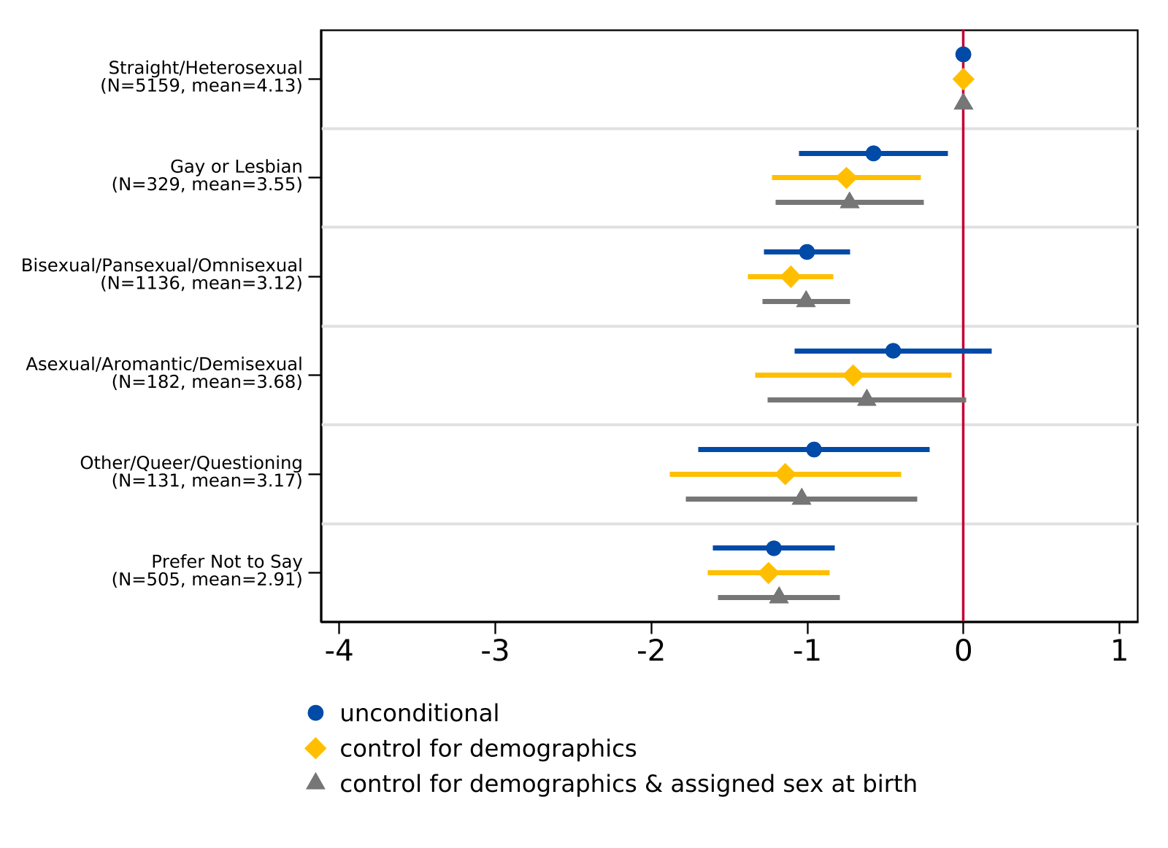
Note. For the unconditional model, n = 7,483. For the model controlling for demographics (race/ethnicity and parental level of education), n = 7,464. For the model controlling for demographics (race/ethnicity and parental level of education) and sex assigned at birth, n = 7412. The lines indicate 95 percent confidence intervals while the sample frequency and mean index of each sexual orientation are reported in parentheses. The vertical line at 0 represents the coefficient for the reference group (straight/heterosexual).

Appendix G: College Worries by Sexual Orientation Robustness
Figure G1
Regression of Composite Index for General College Worries on Sexual Orientation
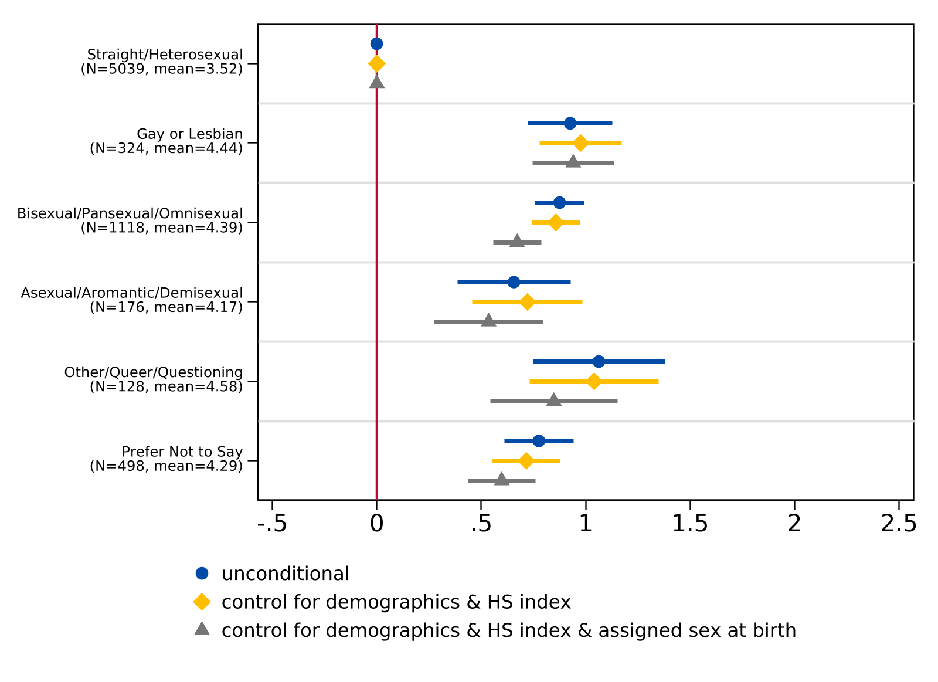
Note. For the unconditional model, n = 7,283. For the model controlling for demographics (race/ethnicity and parental level of education), n = 7,263. For the model controlling for demographics (race/ethnicity and parental level of education) and sex assigned at birth, n = 7,254. The lines indicate 95 percent confidence intervals while the sample frequency and mean index of each sexual orientation are reported in parentheses. The vertical line at 0 represents the coefficient for the reference group (straight/heterosexual).

Figure G2
Regression of Composite Index for College Worries about Discrimination on Sexual Orientation
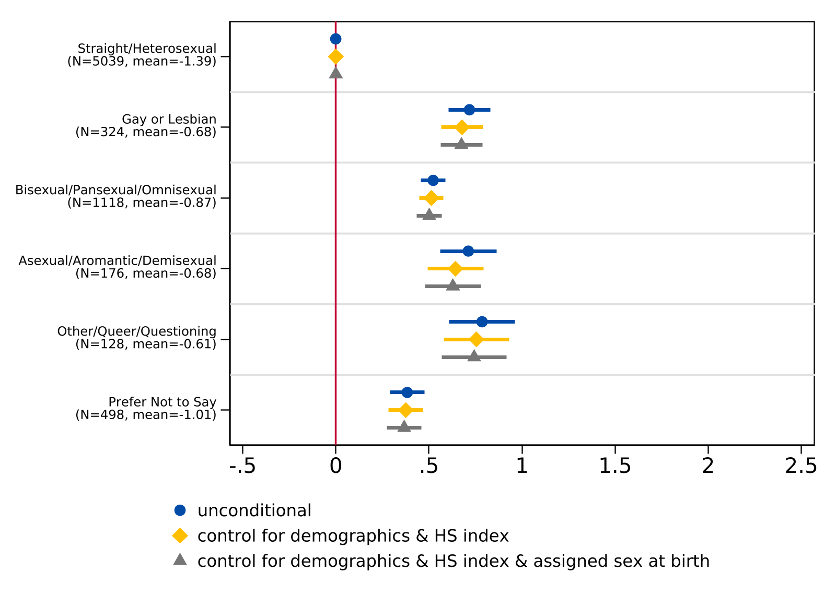
Note. For the unconditional model, n = 7,283. For the model controlling for demographics (race/ethnicity and parental level of education), n = 7,263. For the model controlling for demographics (race/ethnicity and parental level of education) and sex assigned at birth, n = 7,254. The lines indicate 95 percent confidence intervals while the sample frequency and mean index of each sexual orientation are reported in parentheses. The vertical line at 0 represents the coefficient for the reference group (straight/heterosexual).

Figure G3
Regression of Composite Index for College Worries about Financial Burdens on Sexual Orientation
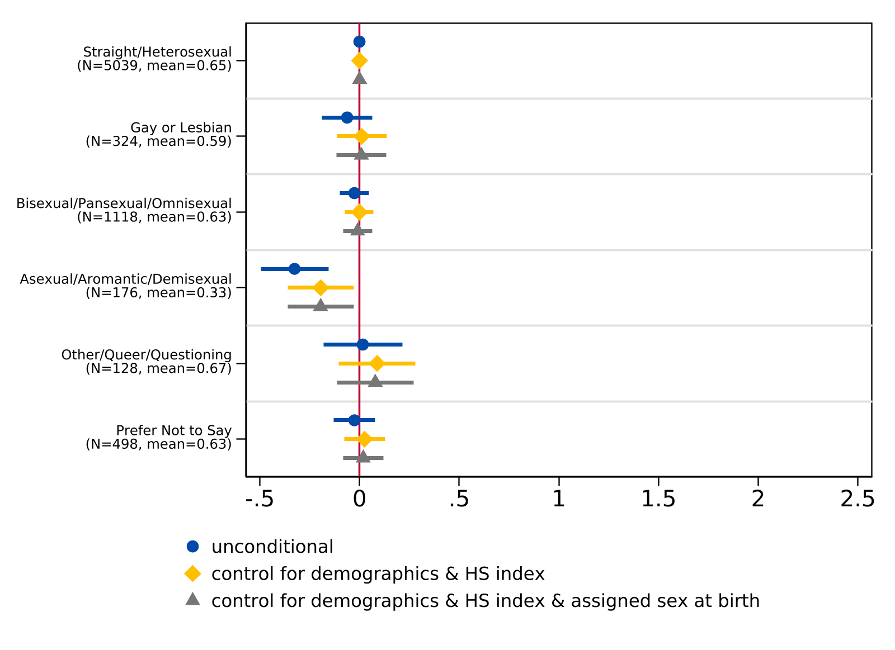
Note. For the unconditional model, n = 7,283. For the model controlling for demographics (race/ethnicity and parental level of education), n = 7,263. For the model controlling for demographics (race/ethnicity and parental level of education) and sex assigned at birth, n = 7,254. The lines indicate 95 percent confidence intervals while the sample frequency and mean index of each sexual orientation are reported in parentheses. The vertical line at 0 represents the coefficient for the reference group (straight/heterosexual).

Appendix H: Raw Estimates from Logit Models

Table H1
Logit Models: Intent to Attend 4-Year College, by Gender Identity
 | (1) | (2)
Cisgender woman | 0.179*** | 0.248***
 | (0.050) | (0.054)
Transgender man | 0.517* | 0.393
 | (0.285) | (0.304)
Transgender woman | 0.541 | 0.416
 | (0.490) | (0.519)
Nonbinary | 0.336** | 0.293**
 | (0.135) | (0.142)
Gender diverse/questioning | -0.279 | -0.384
 | (0.241) | (0.256)
Prefer not to say | 0.111 | 0.095
 | (0.177) | (0.192)
Observations | 7522 | 7498
Demographic controls | No | Yes
Note. Standard errors in parentheses.
* p < 0.10, ** p < 0.05, *** p < 0.01

Table H2
Logit Models: Intent to Attend 4-Year College, by Sexual Orientation
 | (1) | (2)
Gay or lesbian | 0.526*** | 0.404***
 | (0.124) | (0.131)
Bisexual/pansexual/omnisexual | 0.344*** | 0.298***
 | (0.069) | (0.073)
Asexual/aromantic/demisexual | 0.475*** | 0.174
 | (0.163) | (0.175)
Other/queer/questioning | 0.346* | 0.170
 | (0.187) | (0.199)
Prefer not to say | 0.001 | -0.107
 | (0.094) | (0.101)
Observations | 7481 | 7456
Demographic controls | No | Yes
Note. Standard errors in parentheses.
* p < 0.10, ** p < 0.05, *** p < 0.01

Table H3
Ordered Logit Models: Highest Degree Plans, by Gender Identity
 | (1) | (2)
Cisgender woman | 0.487*** | 0.550***
 | (0.045) | (0.046)
Transgender man | 0.553** | 0.508**
 | (0.234) | (0.243)
Transgender woman | 0.178 | 0.049
 | (0.398) | (0.402)
Nonbinary | 0.587*** | 0.604***
 | (0.116) | (0.118)
Gender diverse/questioning | 0.460** | 0.432*
 | (0.223) | (0.229)
Prefer not to say | 0.313** | 0.259
 | (0.158) | (0.161)
Observations | 7497 | 7475
Demographic controls | No | Yes
Note. Standard errors in parentheses.
* p < 0.10, ** p < 0.05, *** p < 0.01

Table H4
Ordered Logit Models: Highest Degree Plans, by Sexual Orientation
 | (1) | (2)
Gay or lesbian | 0.423*** | 0.328***
 | (0.102) | (0.105)
Bisexual/pansexual/omnisexual | 0.492*** | 0.462***
 | (0.060) | (0.061)
Asexual/aromantic/demisexual | 0.420*** | 0.224
 | (0.135) | (0.138)
Other/queer/questioning | 0.365** | 0.257
 | (0.158) | (0.162)
Prefer not to say | 0.150* | 0.048
 | (0.084) | (0.085)
Observations | 7456 | 7433
Demographic controls | No | Yes
Note. Standard errors in parentheses.
* p < 0.10, ** p < 0.05, *** p < 0.01

Appendix I: Predicted Probabilities of Degree Aspirations

Figure I1
Predicted Probability of Degree Aspirations by Gender Identity, Evaluated at Sample Means
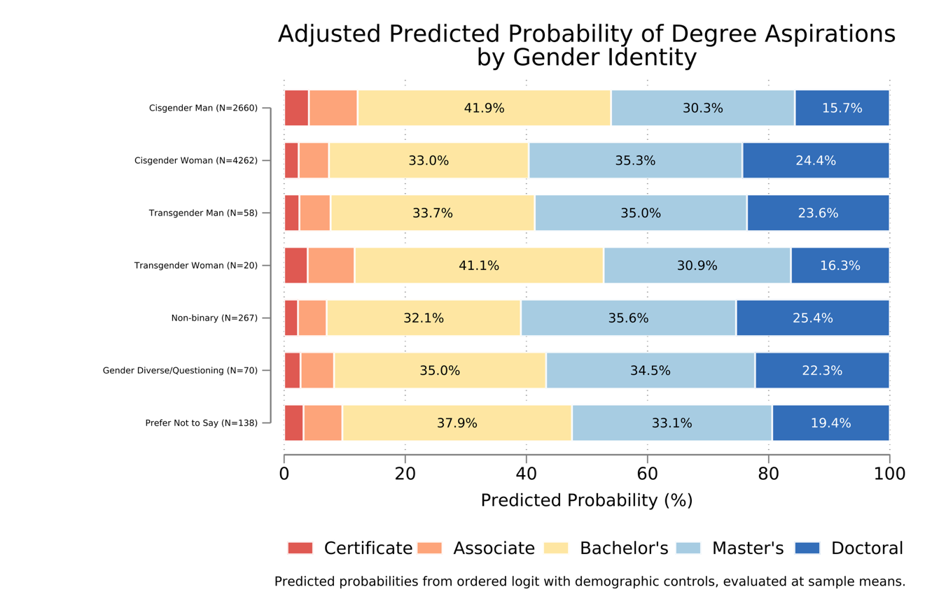
Note: Controlling for demographics (race/ethnicity and parent education).

Figure I2
Adjusted Predicted Probability of Degree Aspirations by Sexual Orientation, Evaluated at Sample Means
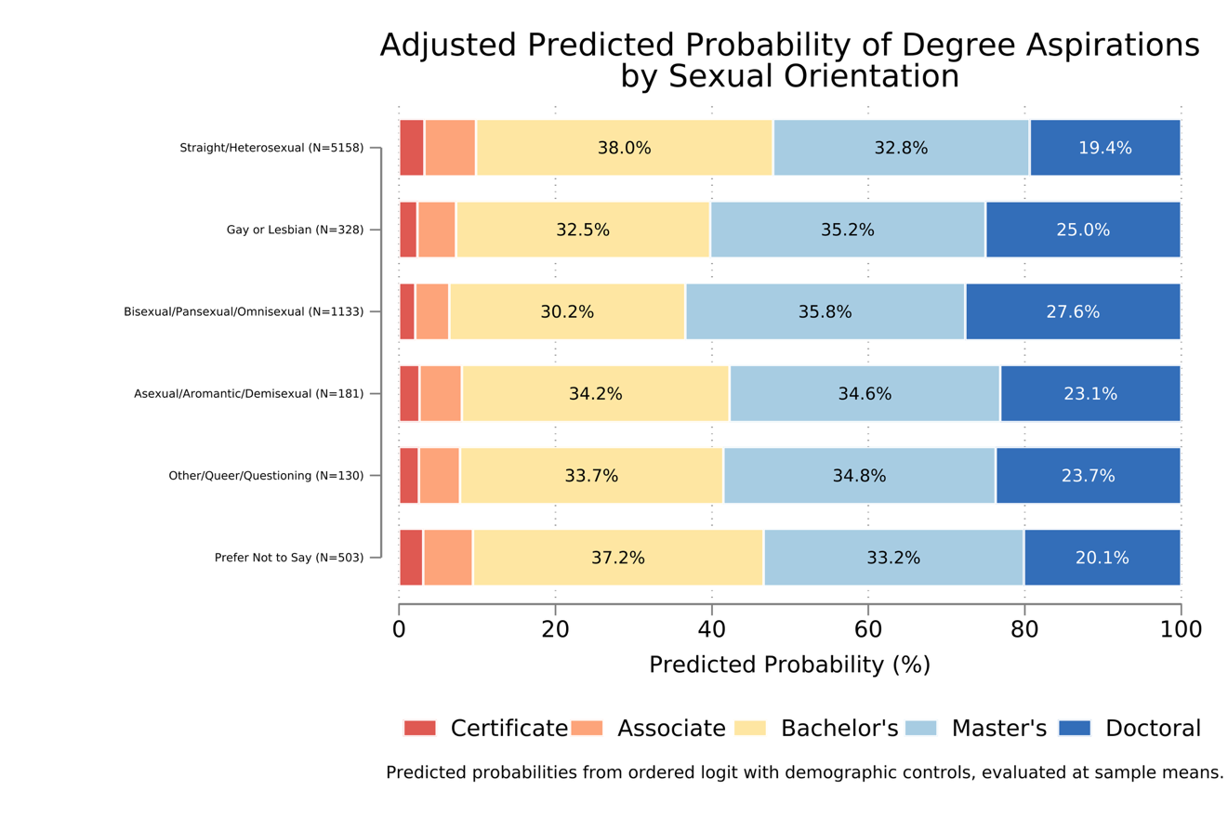
Note: Controlling for demographics (race/ethnicity and parent education).

Figure I3
Adjusted Predicted Probability of Degree Aspirations by Sexual Orientation, Evaluated at Sample Means, Controlling for Assigned Sex at Birth
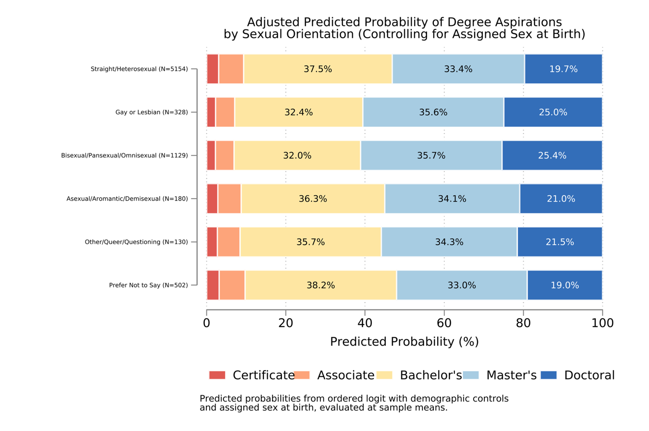
Note: Controlling for demographics (race/ethnicity and parent education) and assigned sex at birth.

This research was approved by the Institutional Review Board (IRB) at the University of California, Davis under protocol number 2041454-1 and considered minimal risk. Informed consent was obtained from all participants prior to survey administration.
Compared to California’s 2022–23 statewide 12th grade enrollment (see Appendix Table A2), our sample is broadly, though imperfectly, representative of the state’s college-bound senior population on several key dimensions. In terms of race and ethnicity, our sample mirrors statewide enrollment, though Hispanic/Latinx students are modestly underrepresented (49.8% vs. 55.7% statewide) while Black/African American and Asian students are slightly overrepresented (7.0% vs. 4.9% and 15.1% vs. 9.5%, respectively). A direct comparison of gender is more difficult to draw given the state reports enrollment using only male, female, and nonbinary categories. With that caveat in mind, our sample skews more female than the statewide enrollment figures would suggest (57.0% cisgender women vs. 48.2% female statewide), which may reflect known patterns of differential college-going rates by gender. Given these differences in how gender is measured, direct comparisons on that dimension should be interpreted with caution.
Of the 266 students who identified as non-binary, 87% (n = 231) were assigned female at birth.
See Appendix B for high school experience survey items and summary statistics.
We also estimate regression models of high school experience index on sexual orientation. For sexual orientation models, we additionally estimate a specification that controls for assigned sex at birth. See Appendix F for results.
PCA is a statistical technique that reduces the dimensionality of complex data by identifying underlying patterns and grouping correlated variables into distinct components/constructs. This approach is particularly useful when analyzing multiple survey items that may measure overlapping concepts, as it allows us to identify the core dimensions of students’ concerns while reducing dimensionality in the data.
Coefficient estimates from models (2) and (3) are very similar, therefore we report only models (1) and (3). We also explore differences in college worry by sexual orientation and additionally estimate a model that controls for demographics, high school experience index, and sex assigned at birth for differences by sexual orientation. Results are reported in Appendix G.
Our dataset for qualitative analysis includes 346 college-bound high school seniors that identify as transgender, nonbinary, or gender diverse/questioning. Summary statistics of our qualitative sample can be found in Appendix E.

